# LAB -1

# CMPE 273 : ENTEPRISE DISTRIBUTED SYSTEMS

# Anuvrat Tiku

# 010822084

# Lab 1 – Using REST (Node.js), HTML 5 and Angular J

**Part 2: Ebay Marketplace**

**Introduction :**

The task is to simulate Ebay.com online shipping website. This has to be accomplished using Node.JS for the server side development, Angular.JS for the MVC framework, Express for the Web Application framework, Bootstrap and CSS for front end styling and MYSQL as the database.

**System Design:**

System is designed with REST architecture in mind. States are transferred on request and responses are fed to the requesting parties. We have used Express JS as the root framework which gives us an elementary application running on a port(3000) in our case. We are provided with an app.js file which is our code dependencies file and all the modules we are using are defined in that file eg. Logger for logging, express, http, router. We can use default node modules that are built in with Node.JS or we can custom create new modules and use them.

App.js file is also the core routing file. It is the source for all POST and GET requests in our application. This files also does session management for us using cookies.

REST:

We have two ways of communicating with resources in our applications : POST and GET. Whenever, we want to fetch some resources and the server will provide us with them, mostly web pages is a GET request. Whenever we have to send some information(like form details) to a function handling the form on the server side, it is done using a POST request. POST will pack the information to be sent in an http post request and send it to the server via our MVC framework : Angular JS.

Angular JS:

We are using Angular 1.5 as out MVC framework. Angular acts as a buffer between the web page and the Node server for all http requests. Angular is also used for form validation and show/hide errors if any. Angular uses the following to control html behavior.

1. Directives : HTML annotations that trigger JavaScript behavior

2. Modules : Where our application lives

3. Controllers : Where we add behavior

4. Expressions : How values get displayed within the page.

Normally without angular, on every request, the browser loads the complete web page completely. Even if there is a change in a small portion of the web page, the entire web page is refreshed. The architecture is not efficient as most of the elements in the web page are unnecessarily loaded. This can be avoided with Angular JS. What happens is that the browser only updates a small part of the web page which it receives through JSON. This is done through data binding. To summarize, Angular is a client side JS framework to add interactivity to HTML.

MySQL :

We are using the Oracle's MySQL for storing our data in the application. MySQL is a relational database from Oracle that stores that data in tables in database schema. Data is fetched from tables using SQL queries and result is passed on the the server.

Bootstrap/CSS :

Bootstrap and CSS are styling libraries in HTML that app appeal to our web page. We have extensively used bootstrap components like container(used on every page) and well to gracefully display data.

Node:

Server side development is done using Node JS.

More regarding the system design will be explained in the below screenshots.

**RESULTS :**

(a) :Sign In, Sign up

The user should have to sign up in order to use the application. In order for a registered user to view the homepage and start shopping, he should have to log in first. Home page should not be visible prior to sign in.

Sign/up page :

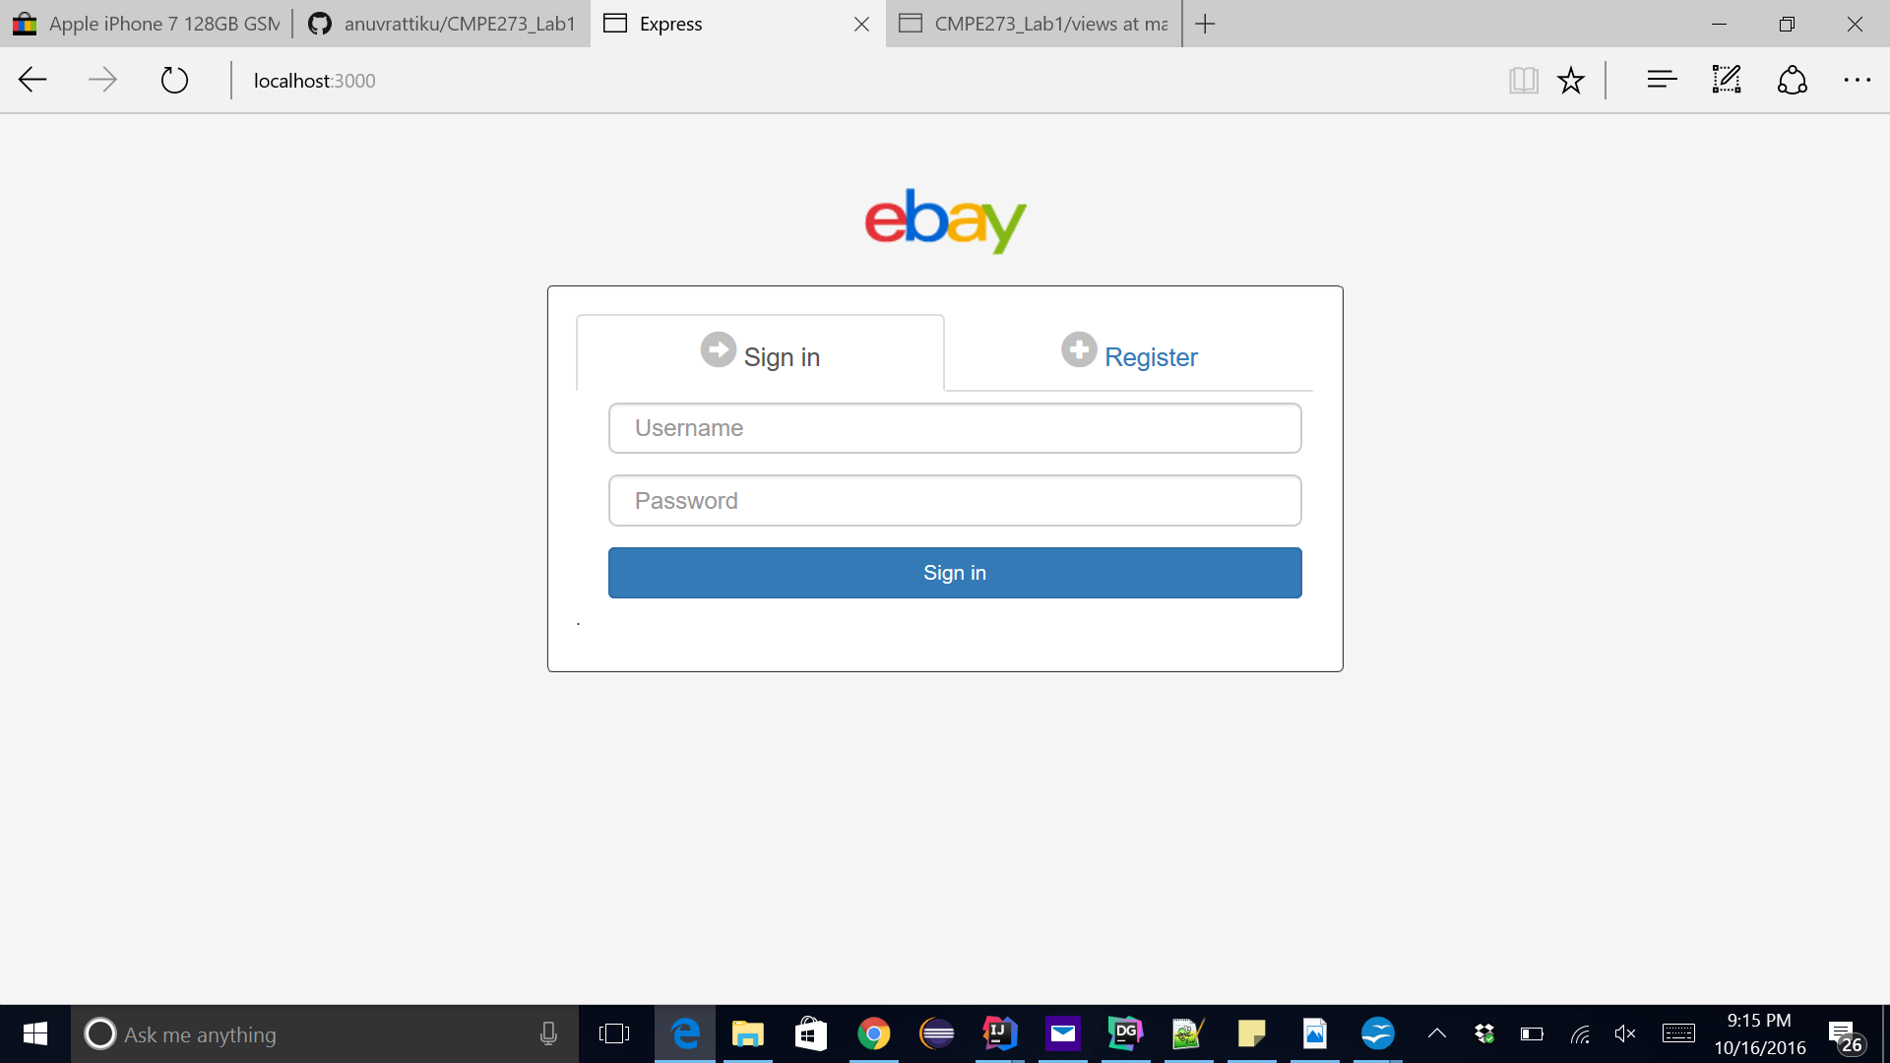

This page has 2 bootstrap tabs called “nav nav-tabs” which toggle on click. Right now by default the user on hitting the URL is shown the Sign in tab where he has to enter his user name and password.

If the user is successfully authenticated, he is redirected to the homepage where all the products are displayed.

On clicking on the register tab, the tab is toggled and user is shown the Register option.

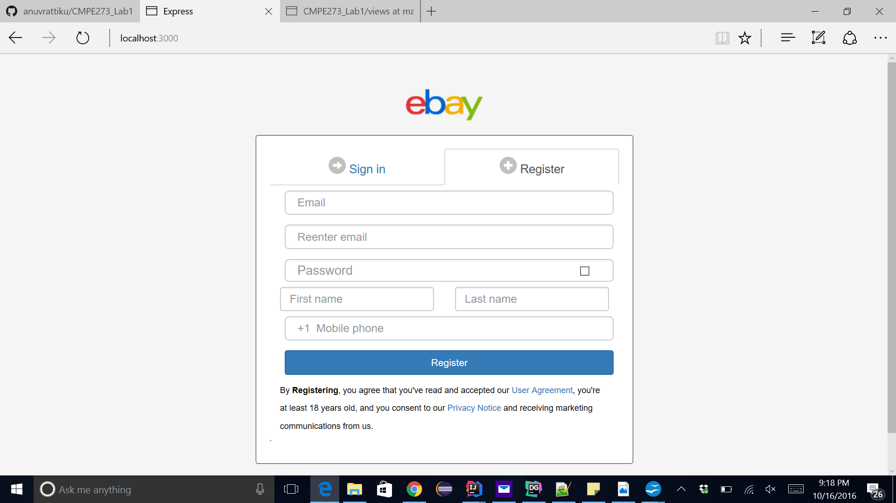

Here user who is new to the application can enter his basic details for signing up after which he is also redirected to the home page.

Both sign in and sign up page have a lot of validations.

If username and password entered does not match the the values in the database, we error is displayed:

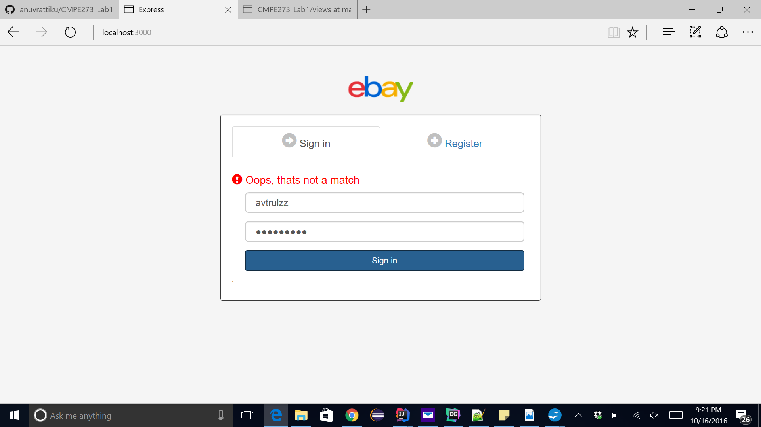

We can see that an error message is displayed on screen if the user id or password is incorrect.

We can also see the error message on the terminal.

Terminal logs show invalid login :

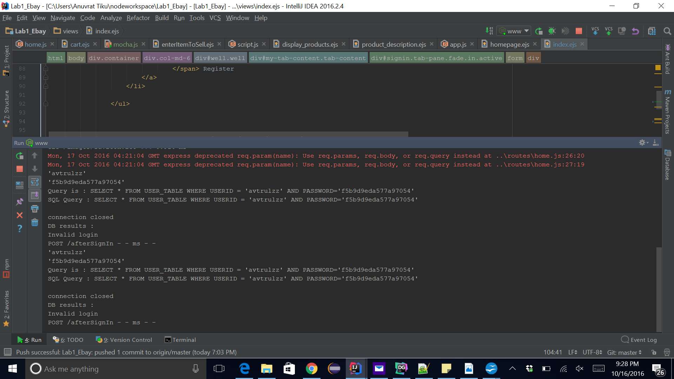

This error is displayed using a ng-show/hide property of Angular with the condition being false and displaying the error message.

We refresh the page again and the error will be gone.

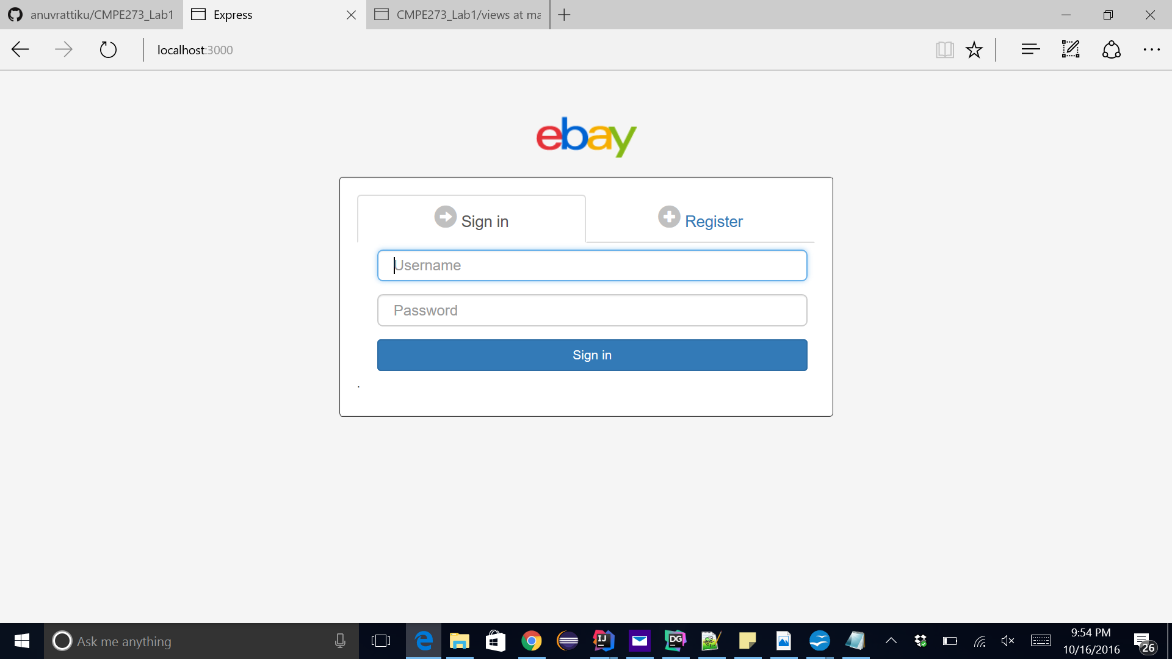

This time we enter the correct username and password and click on Sign In.

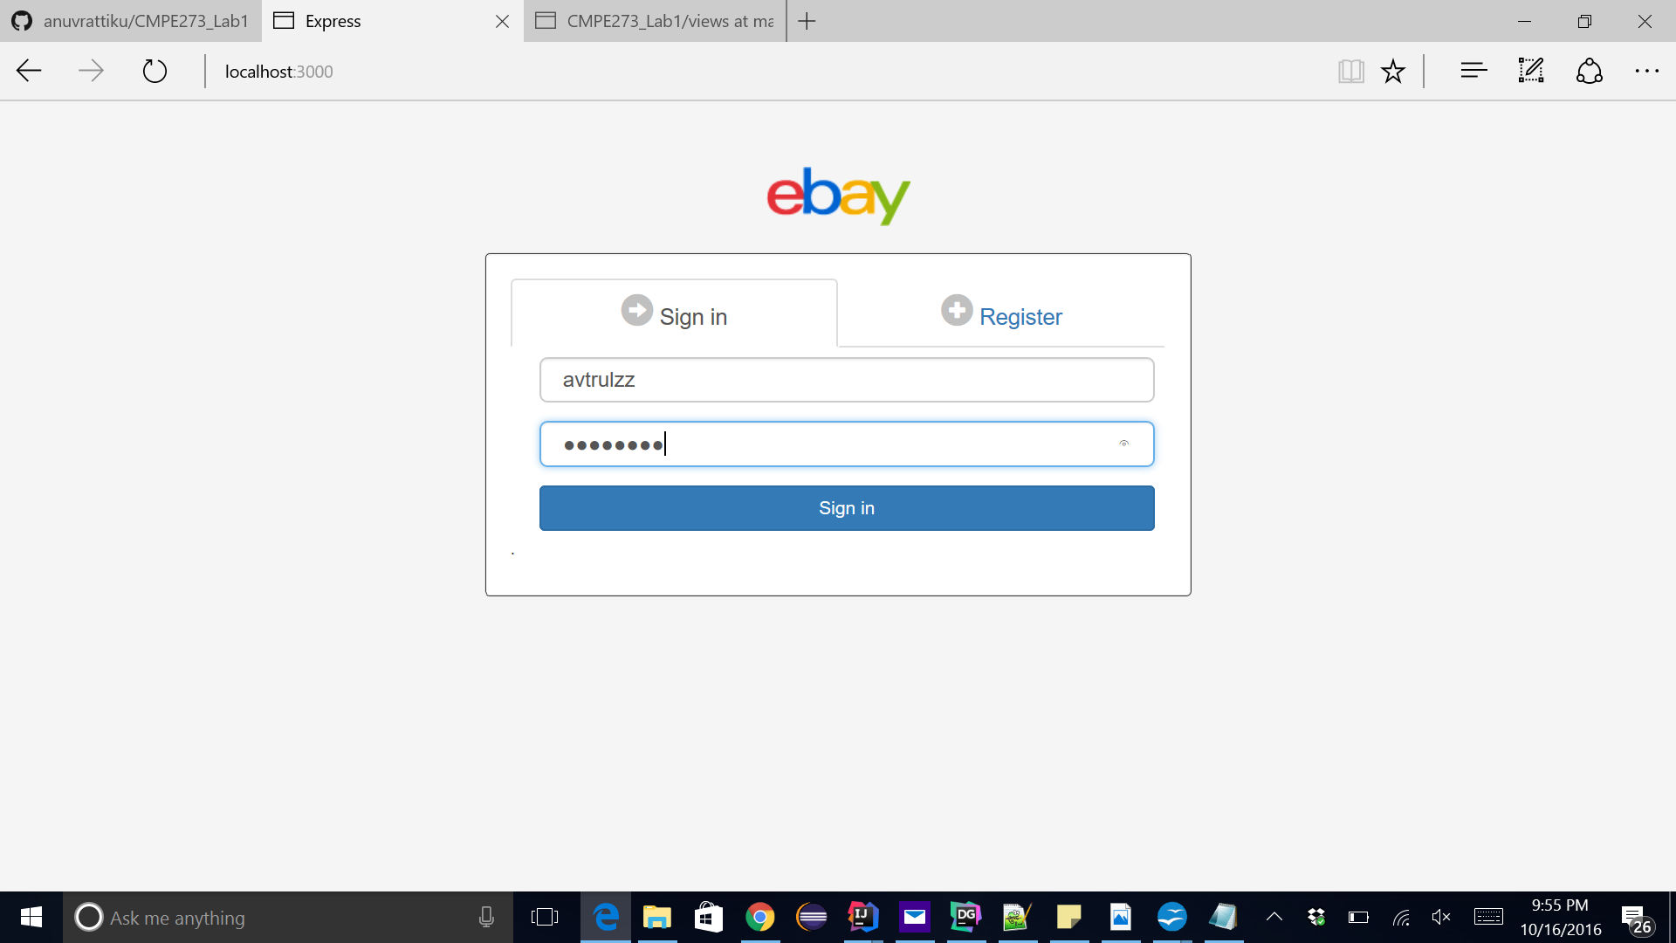

Viola , we are directed to the homepage:

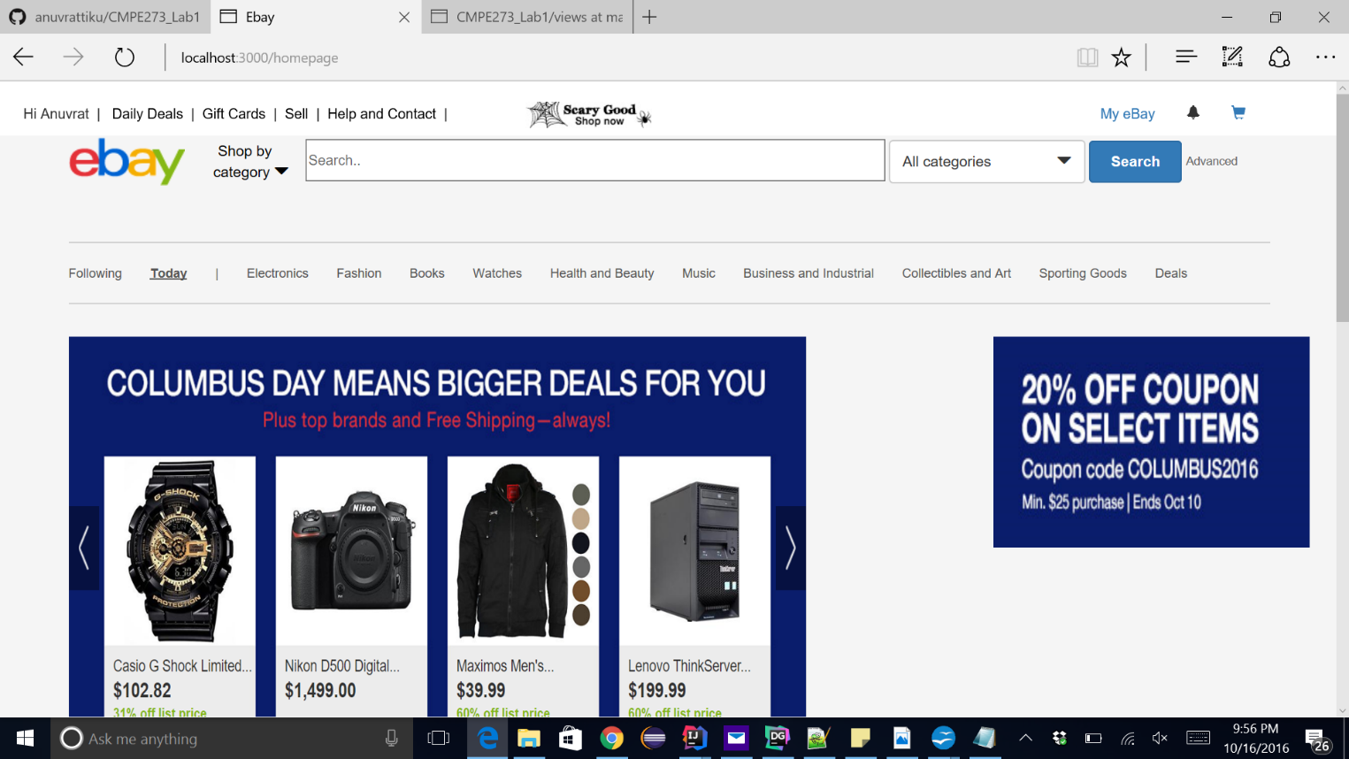

Logs show that we have logged in successfully:

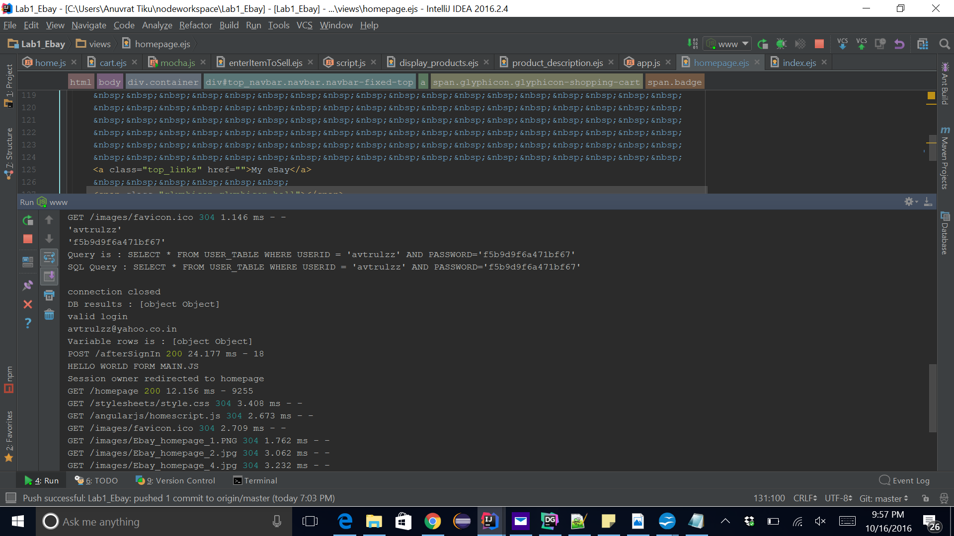

We will try sign up now:

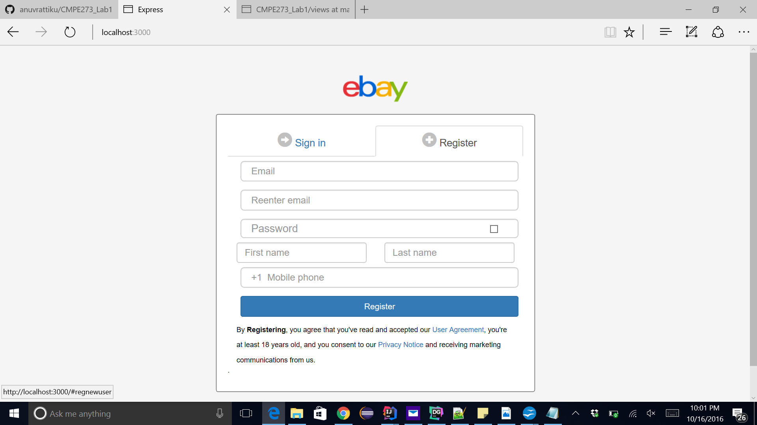

Every field on this page is required and user cannot proceed forward without filling a field.

If user tabs into the email field and then tabs out without entering any information or the field is ng-pristine, error will be displayed.

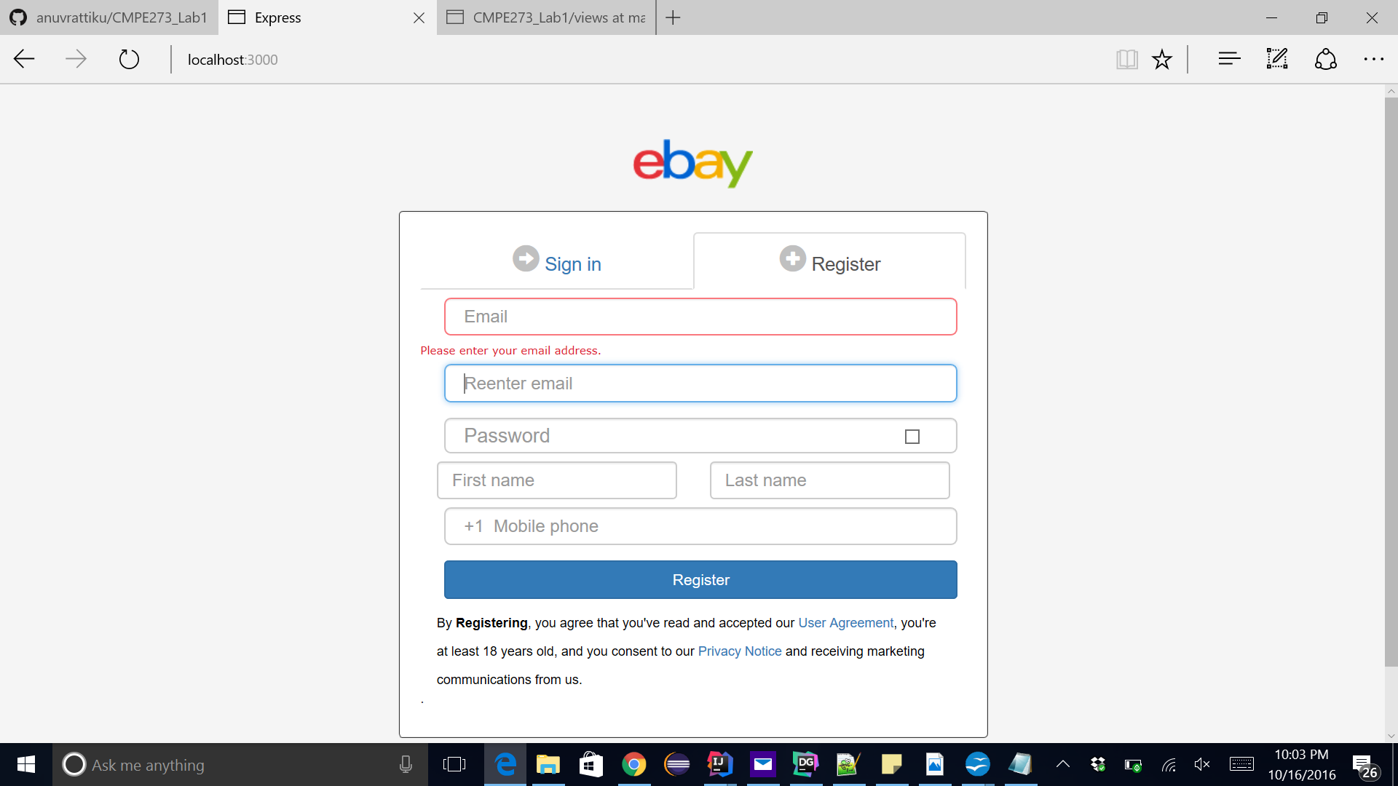

Similarly for re-enter email address field.

Now we will enter both the values and both the values should logically match as they are the same email ids. If the values do not match, error message is thrown.

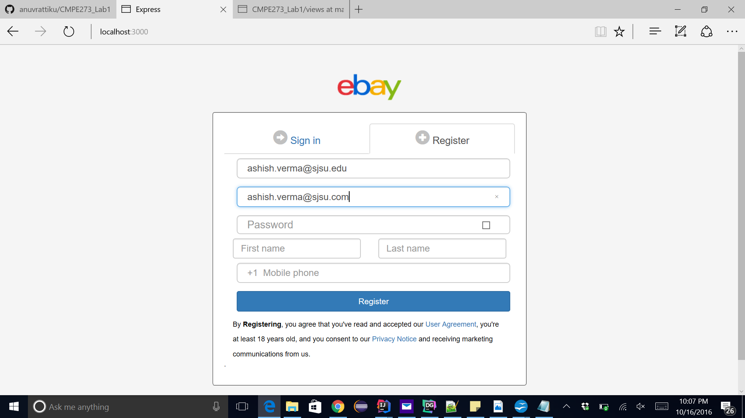

The two ID's do not match and on tab out error should be thrown as expected.

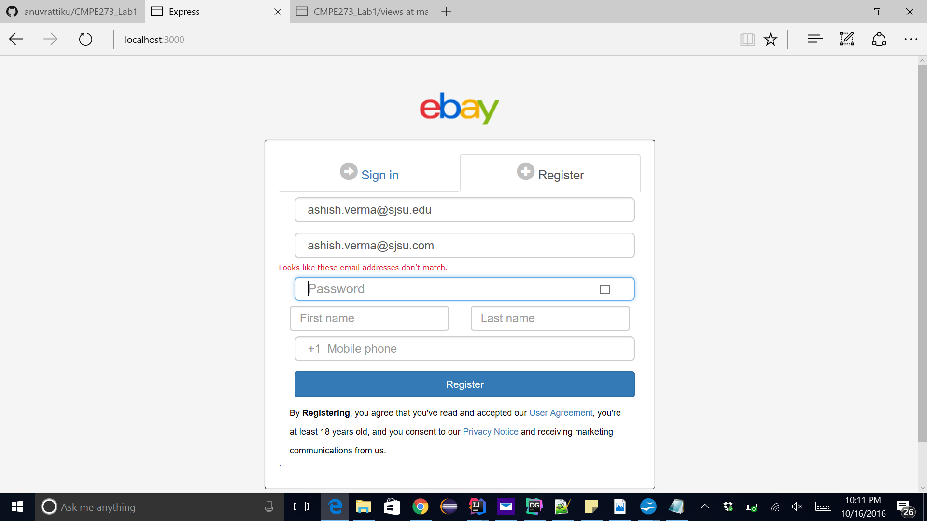

Once we correct the email addresses, we get no error message.

Password field has 2 validations :

1. It should not be blank
2. It should be more than 6 characters

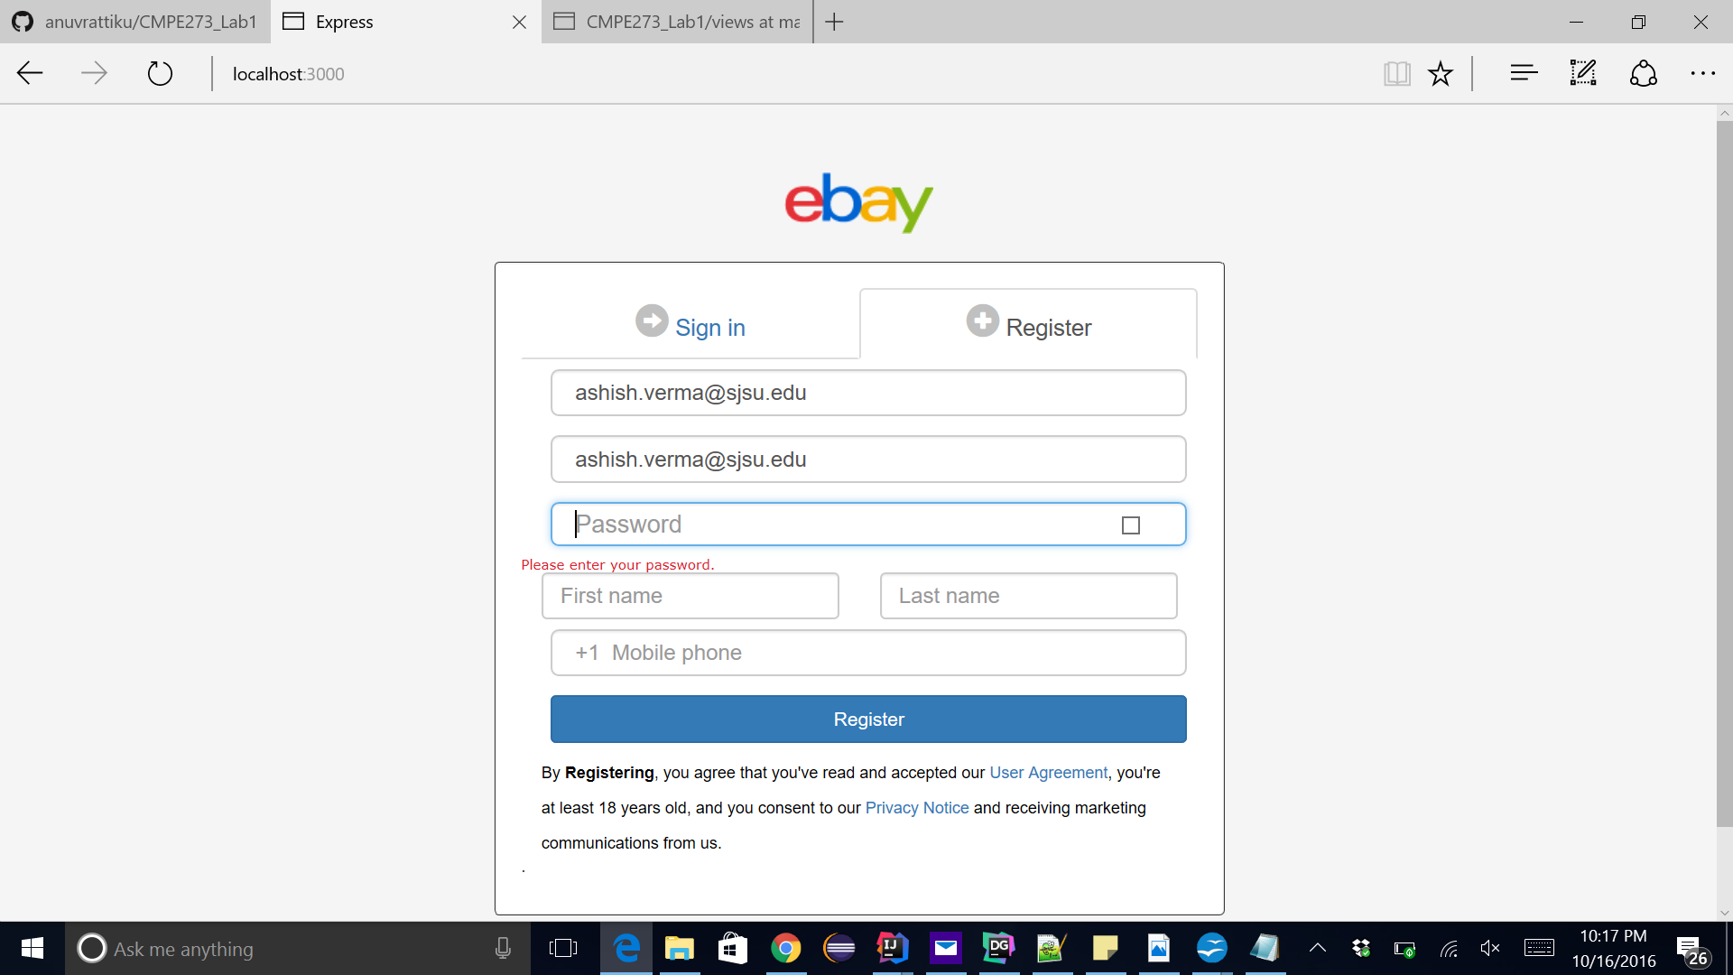

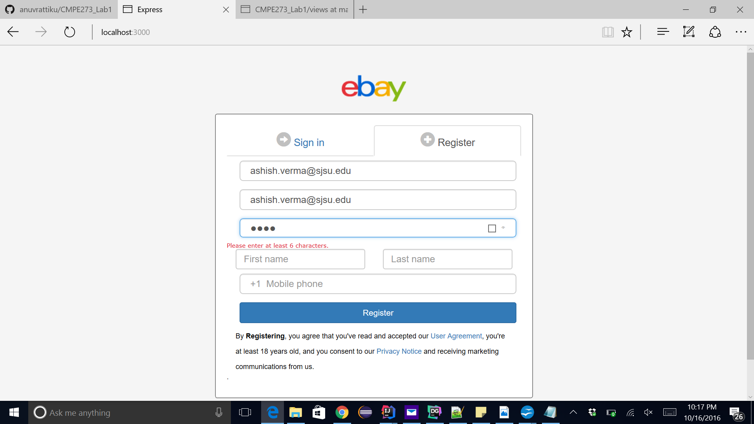

Check box also shows the password we have entered

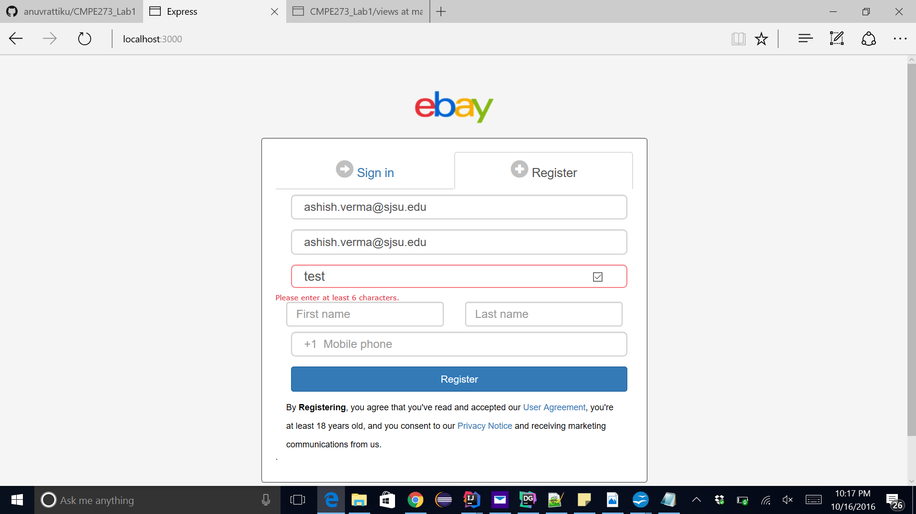

Error is gone after entering > 6 characters

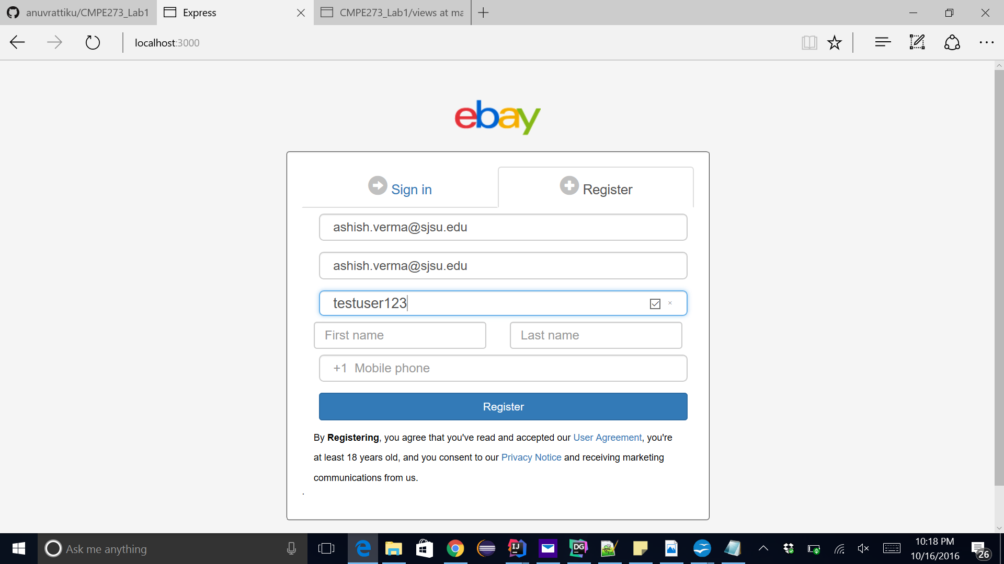

Similarly other fields also have such validations and on clicking register :

User is registered into the database and from now on ca use the system for shipping using his credentials.

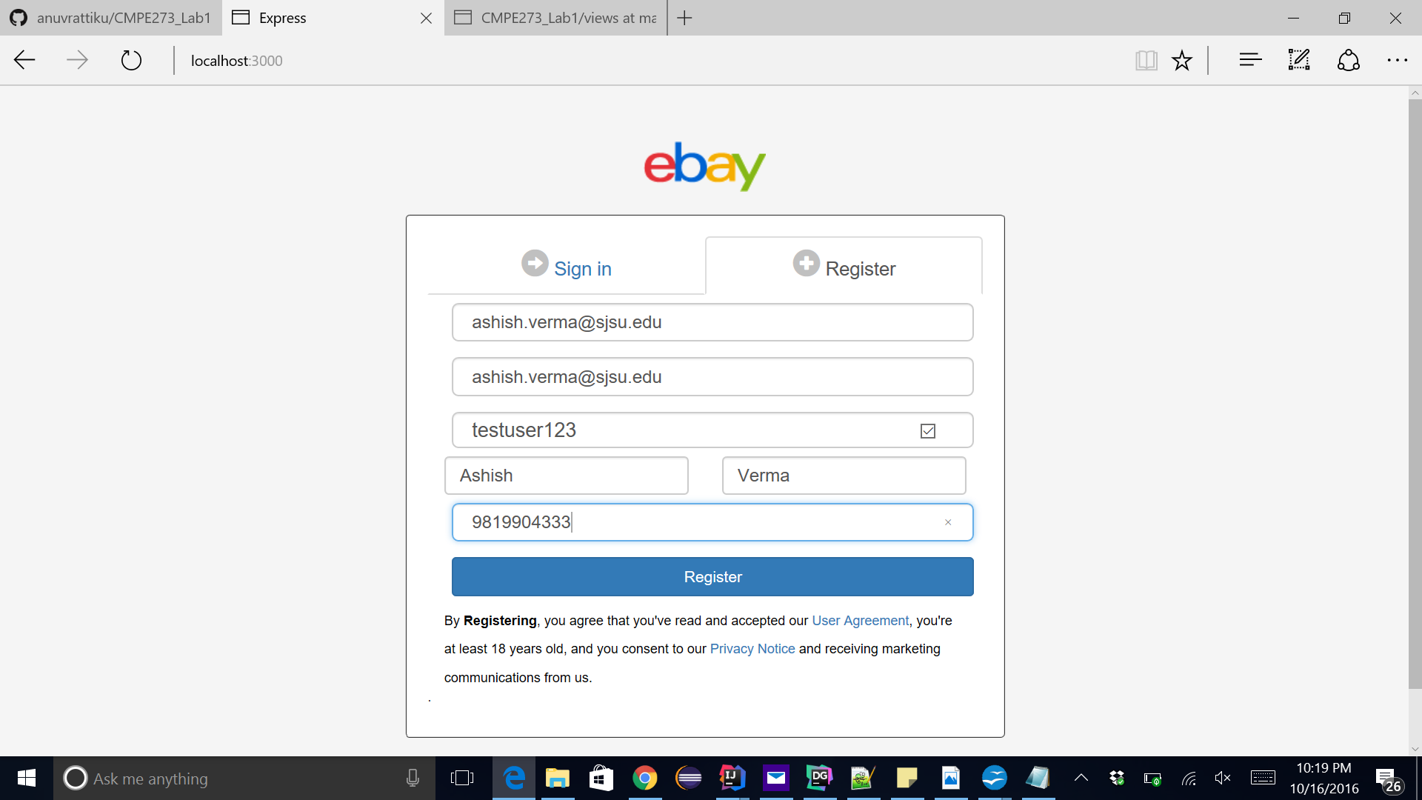

User has been successfully signed up :

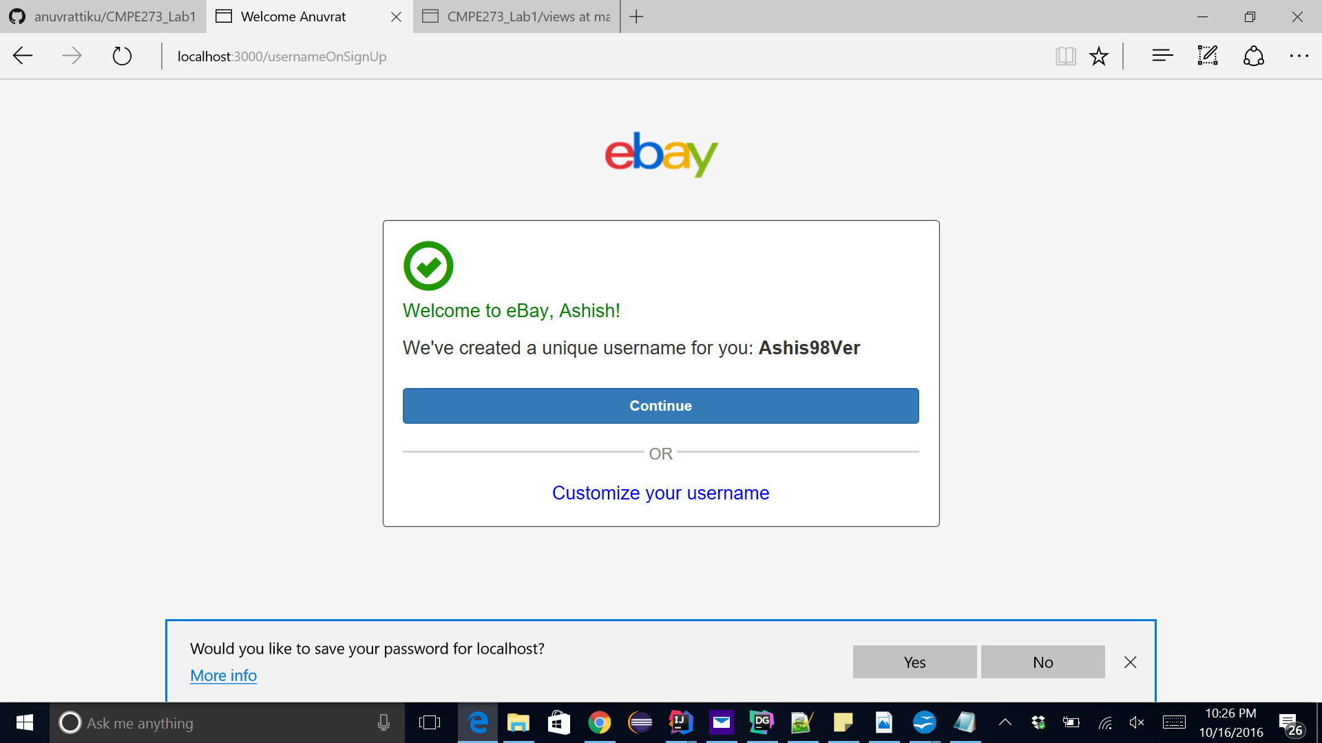

Here we have the option to customize out username or move to the home page.

Customizing our username

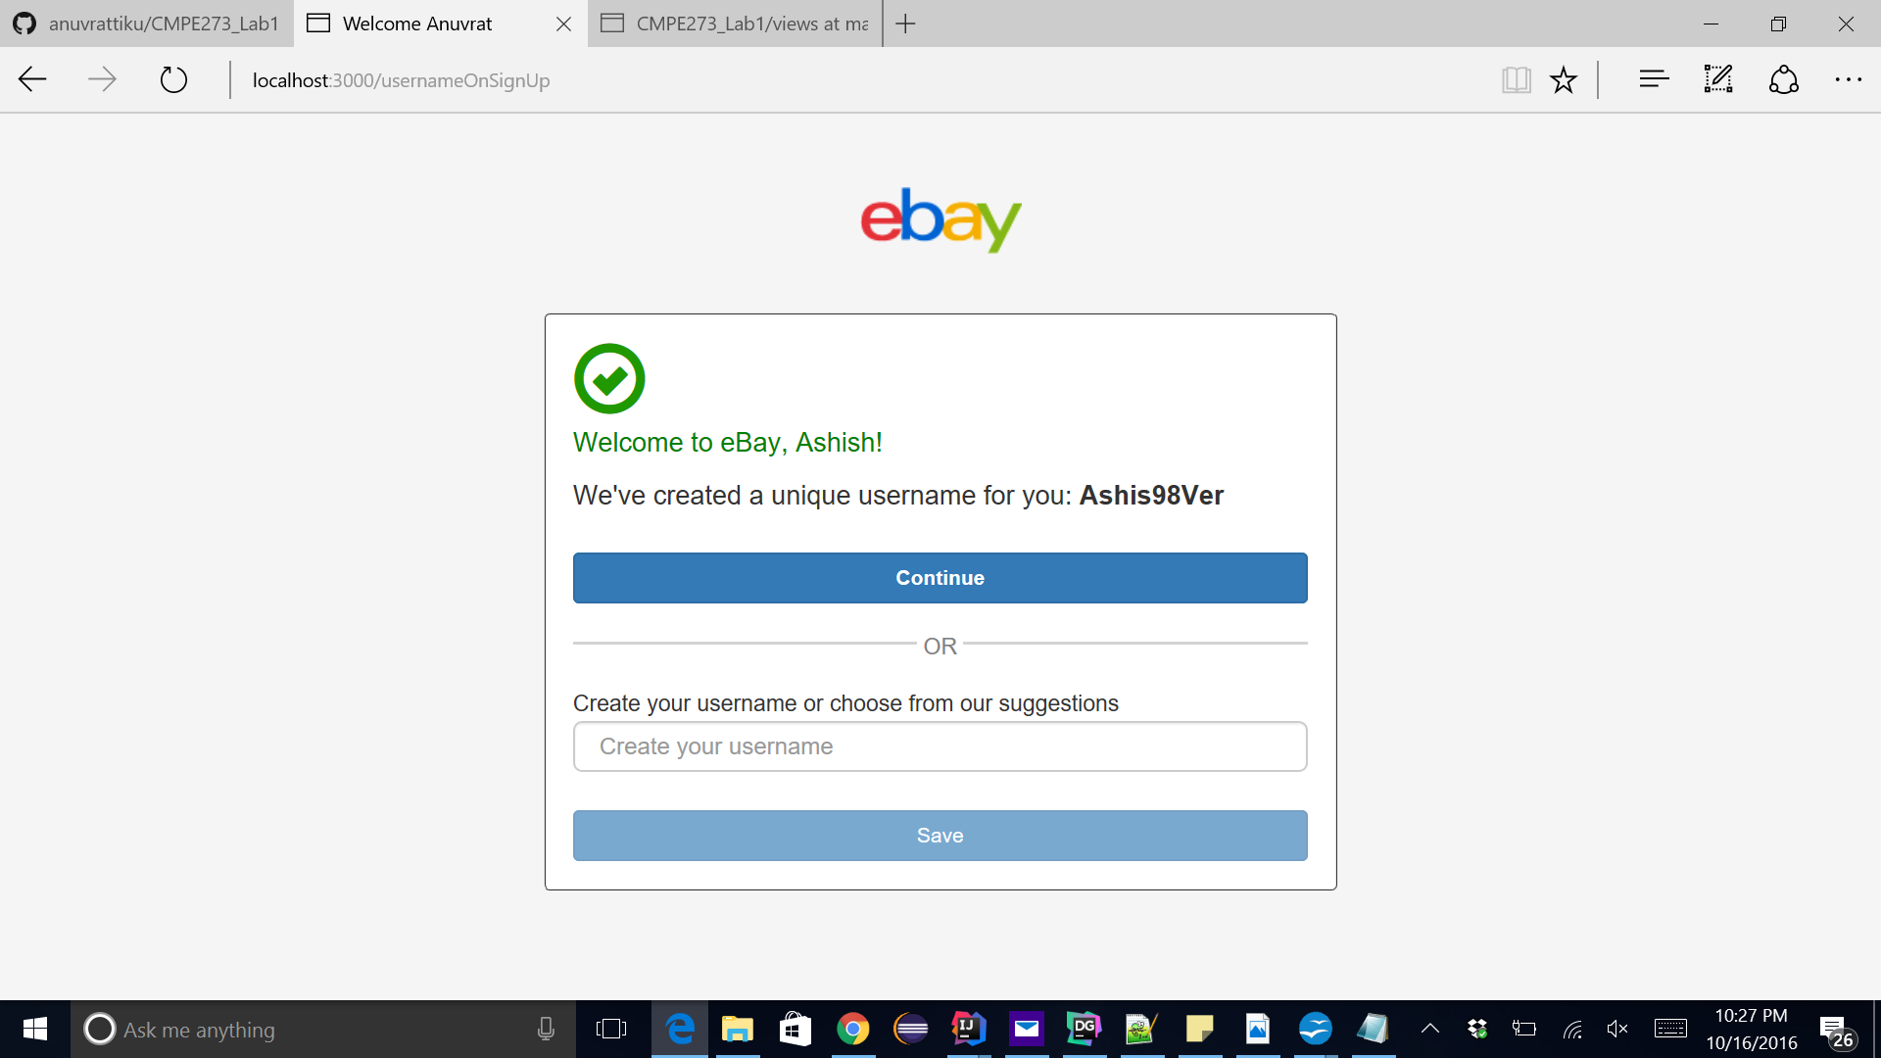

We will customize it to ashish. On saving username will be changed to ashish.

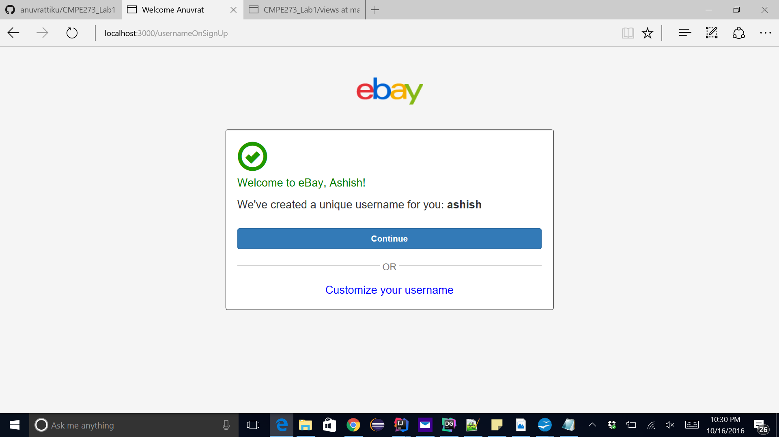

Now we can move to the Home page on clicking continue:

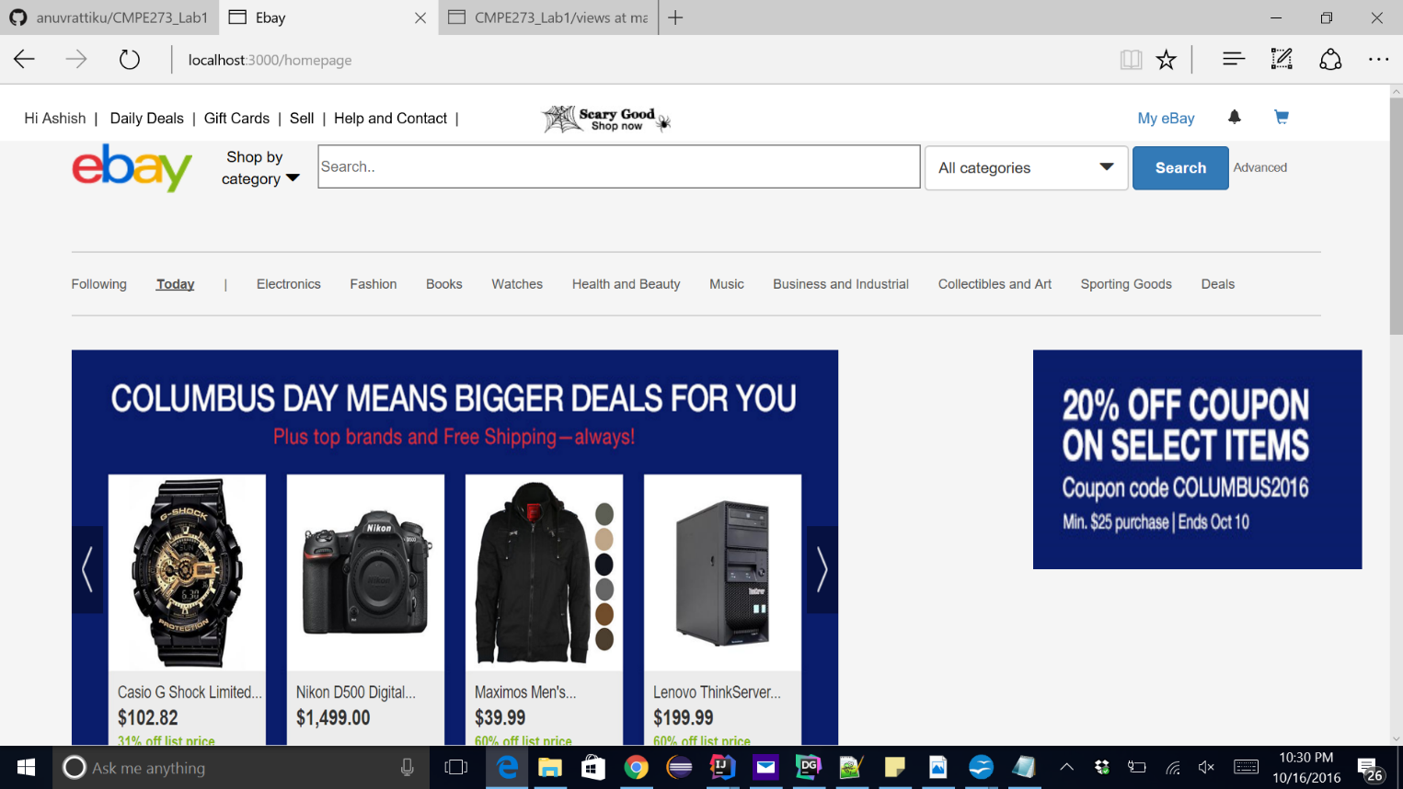

Logging in using the root user : avtrulzz

We are logged in with the user avtrulzz and we should be displayed all the products listed by all other users other than avtrulzz.

We click on the search button on top

This will display all the products :

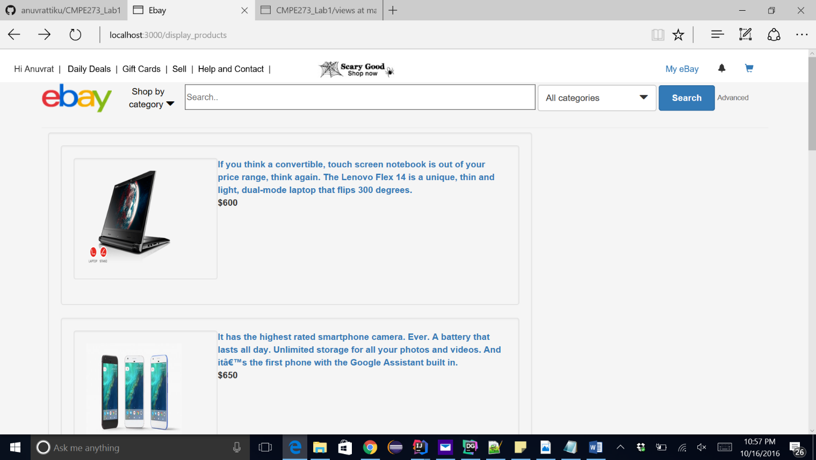



This displays all the products on the screen for the user to see.

We can also add out own listing products.



This is the page where we add all the products



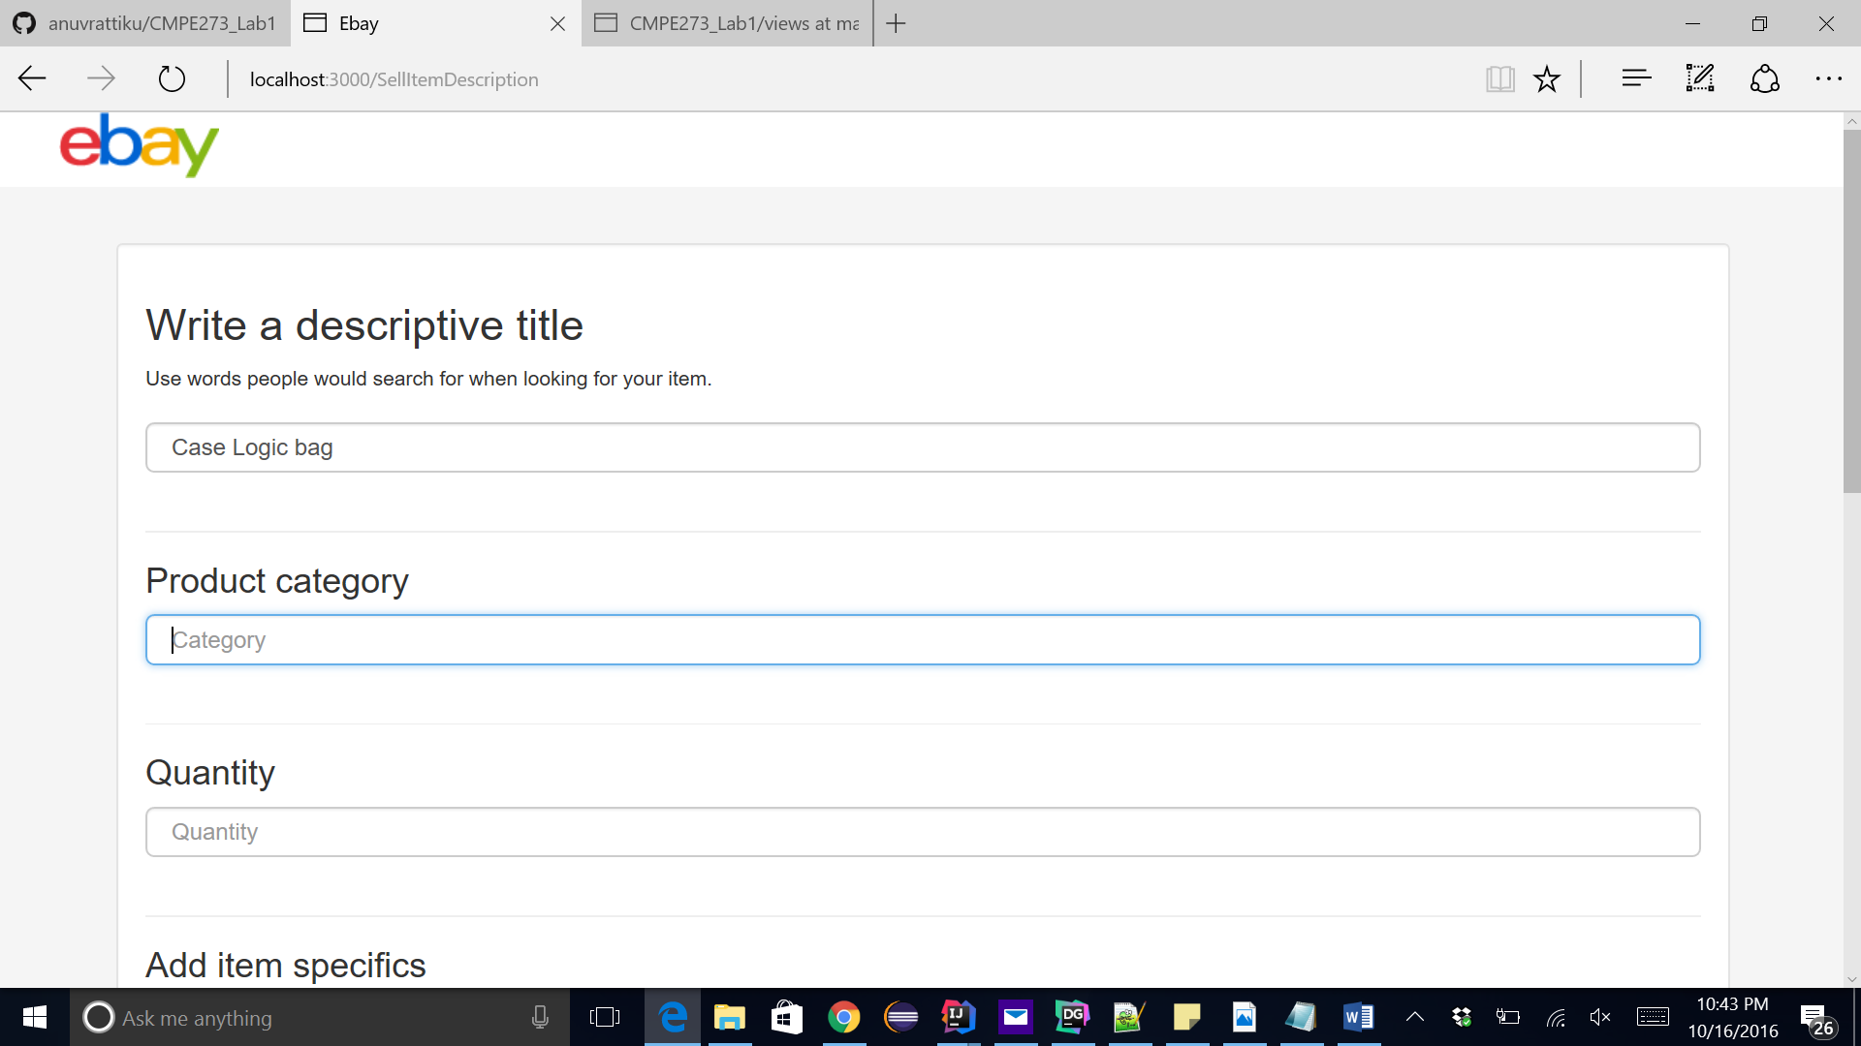

Here we can enter all the Listing specific information for the product.

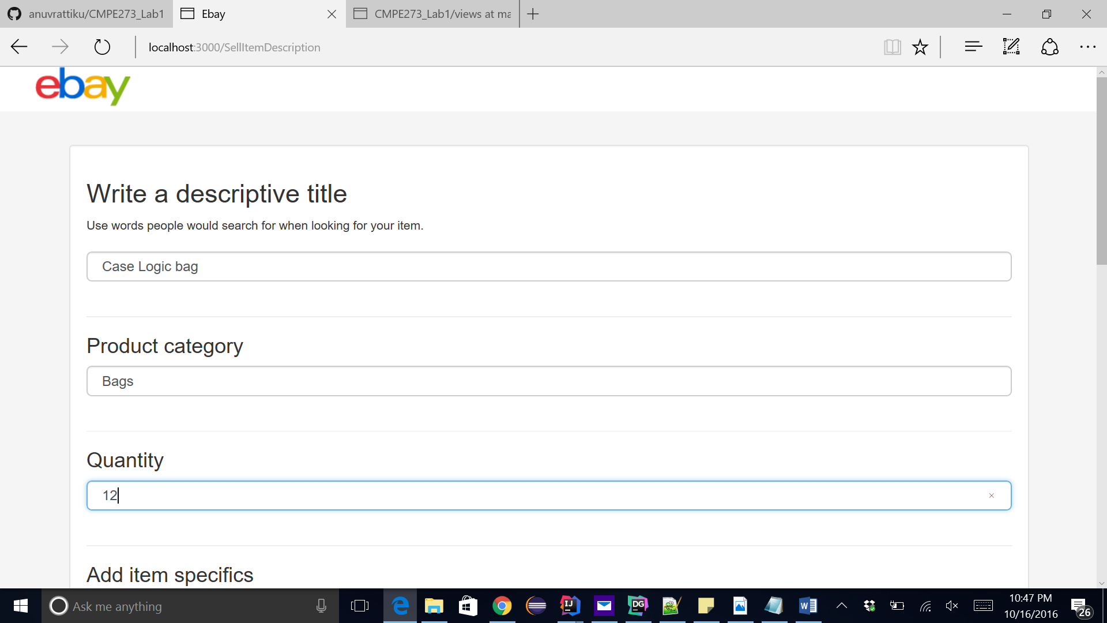

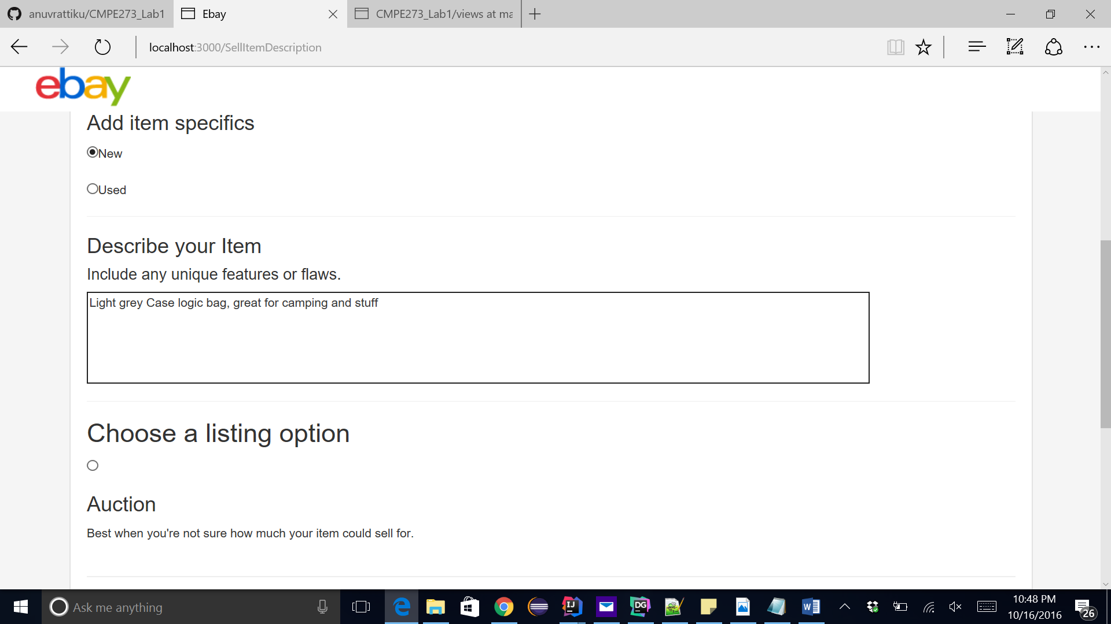

Listing types are 2, auction and sell

If user selects Auction, he is told to enter a starting price and if he enters sell, he is asked to enter a fixed price.

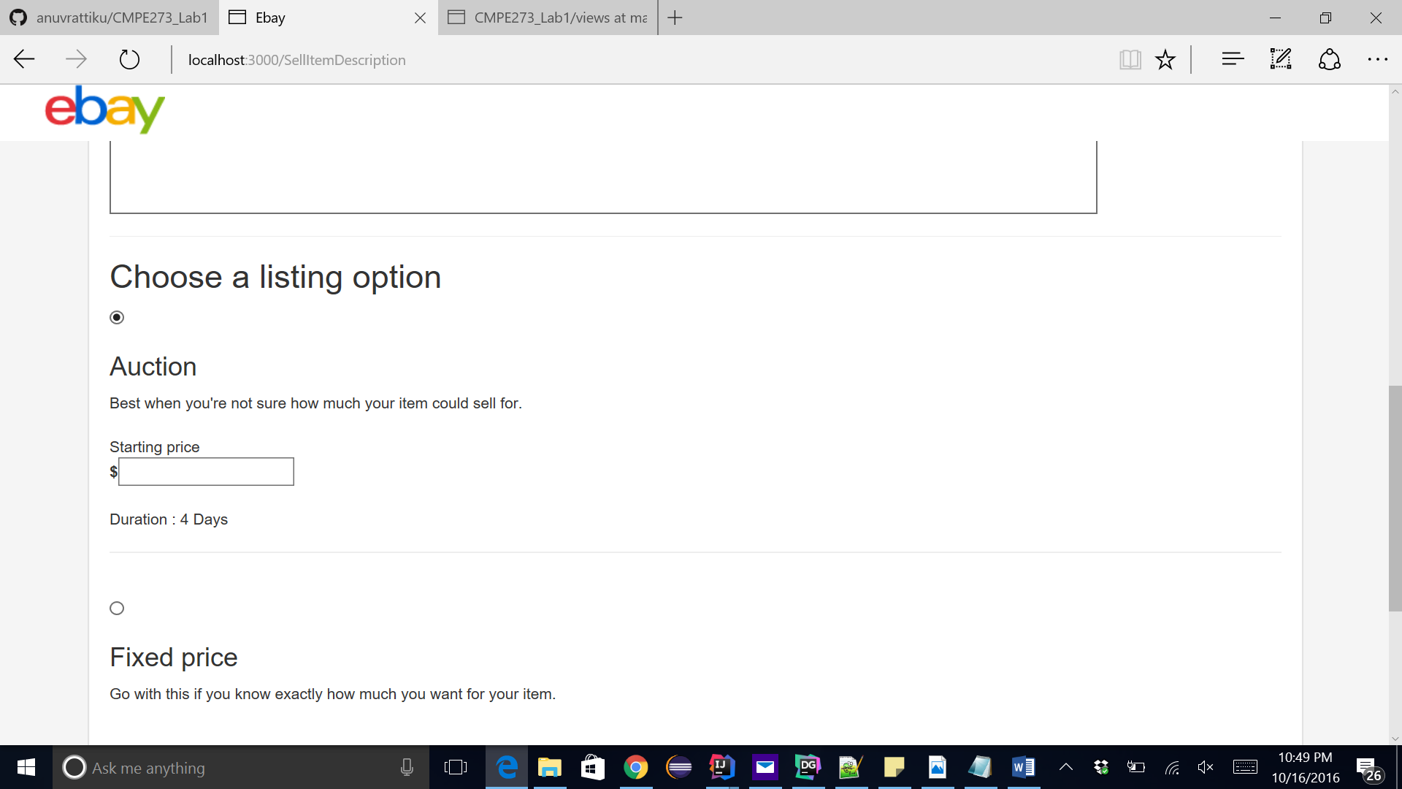

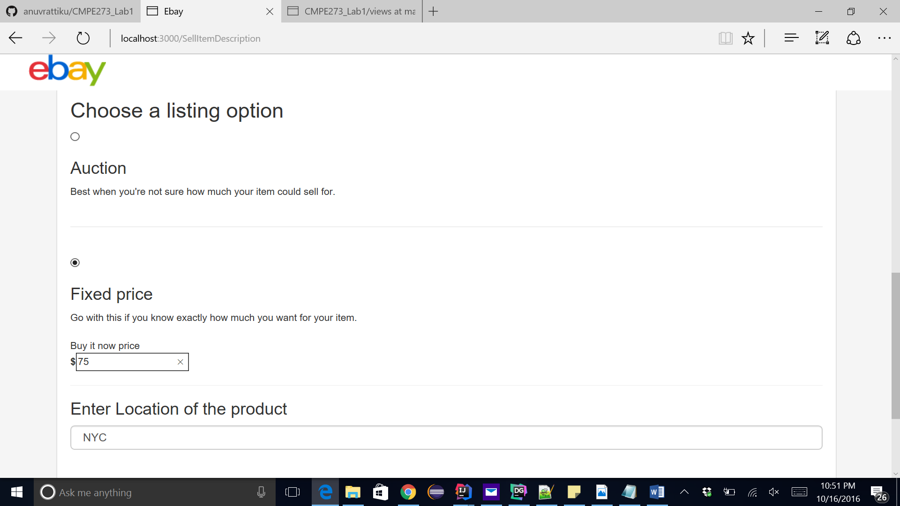

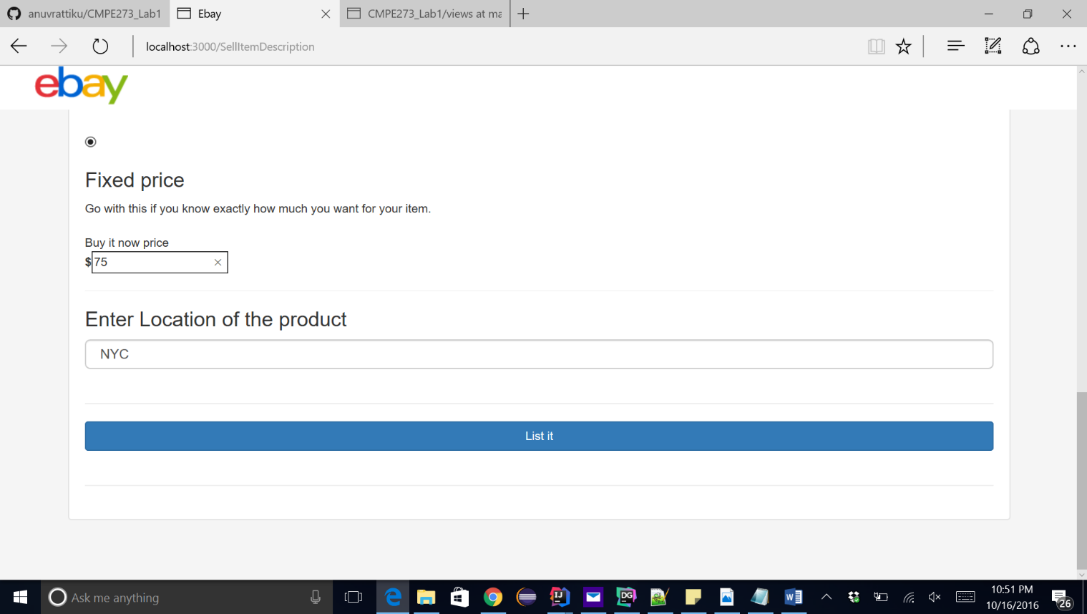

Click on List it to list the product

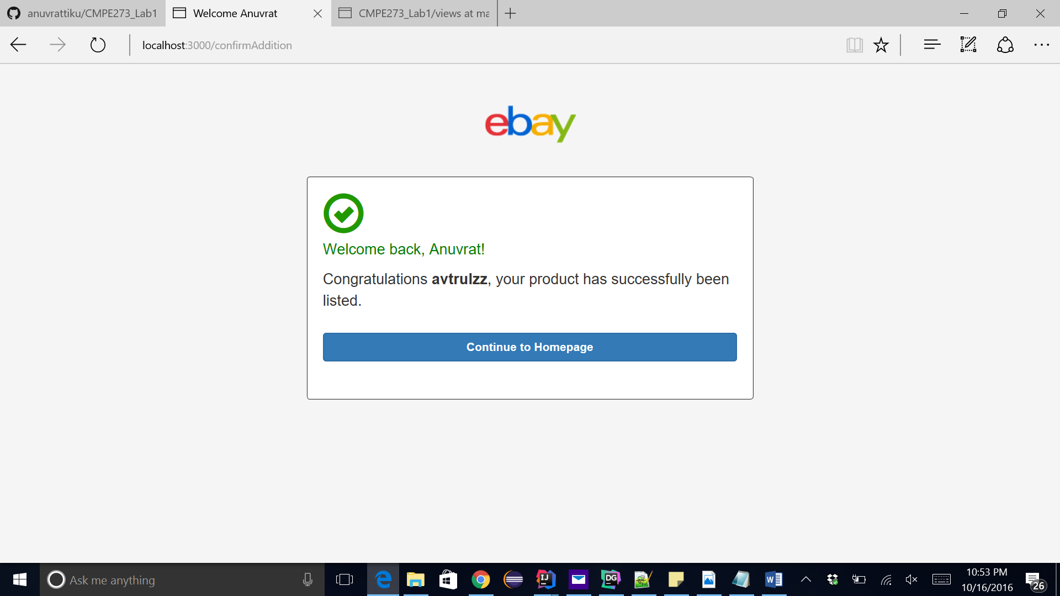

We can continue to homepage

Back to where we can all the products

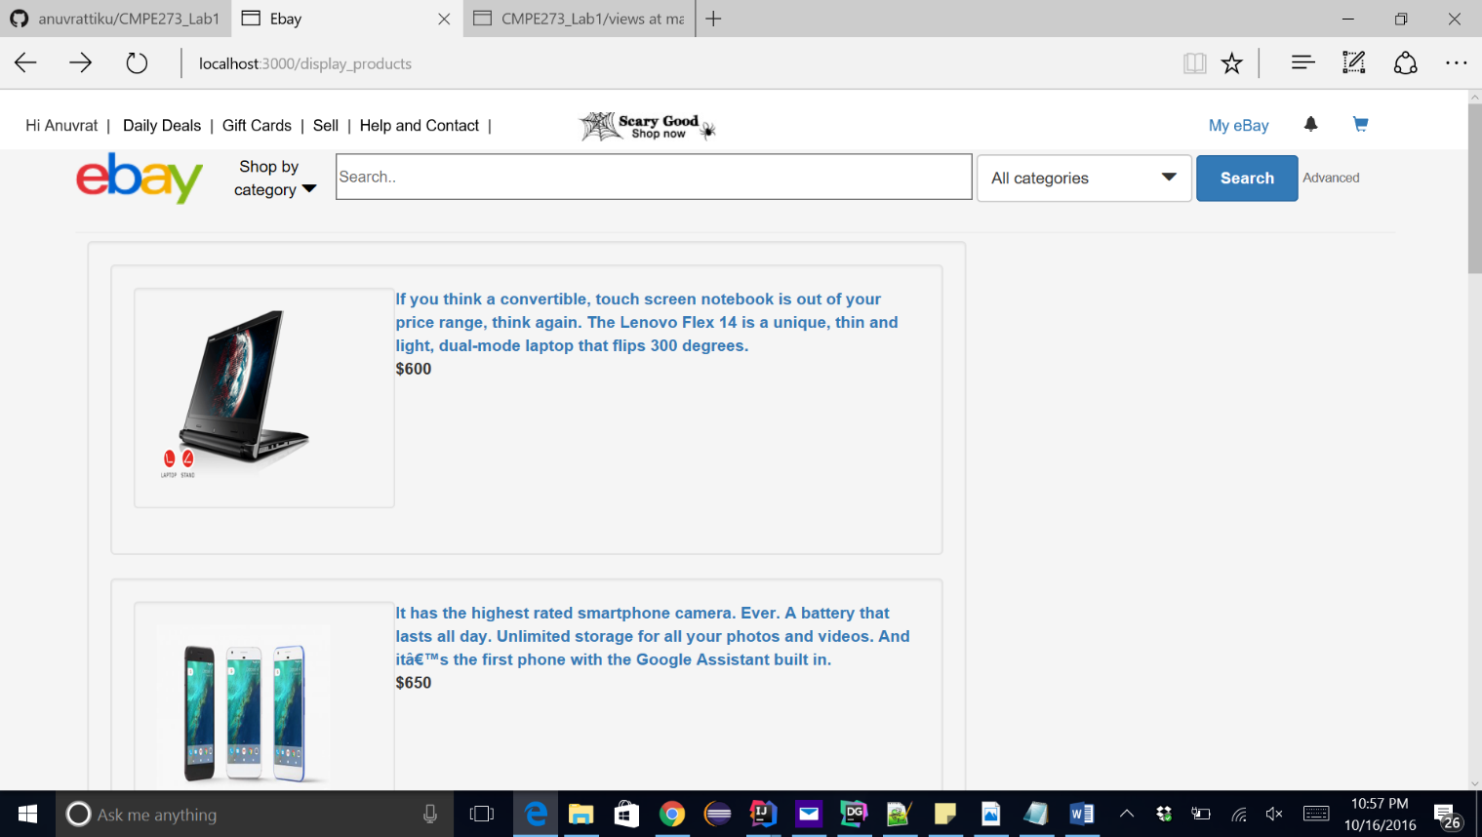

We will add a few products to the cart

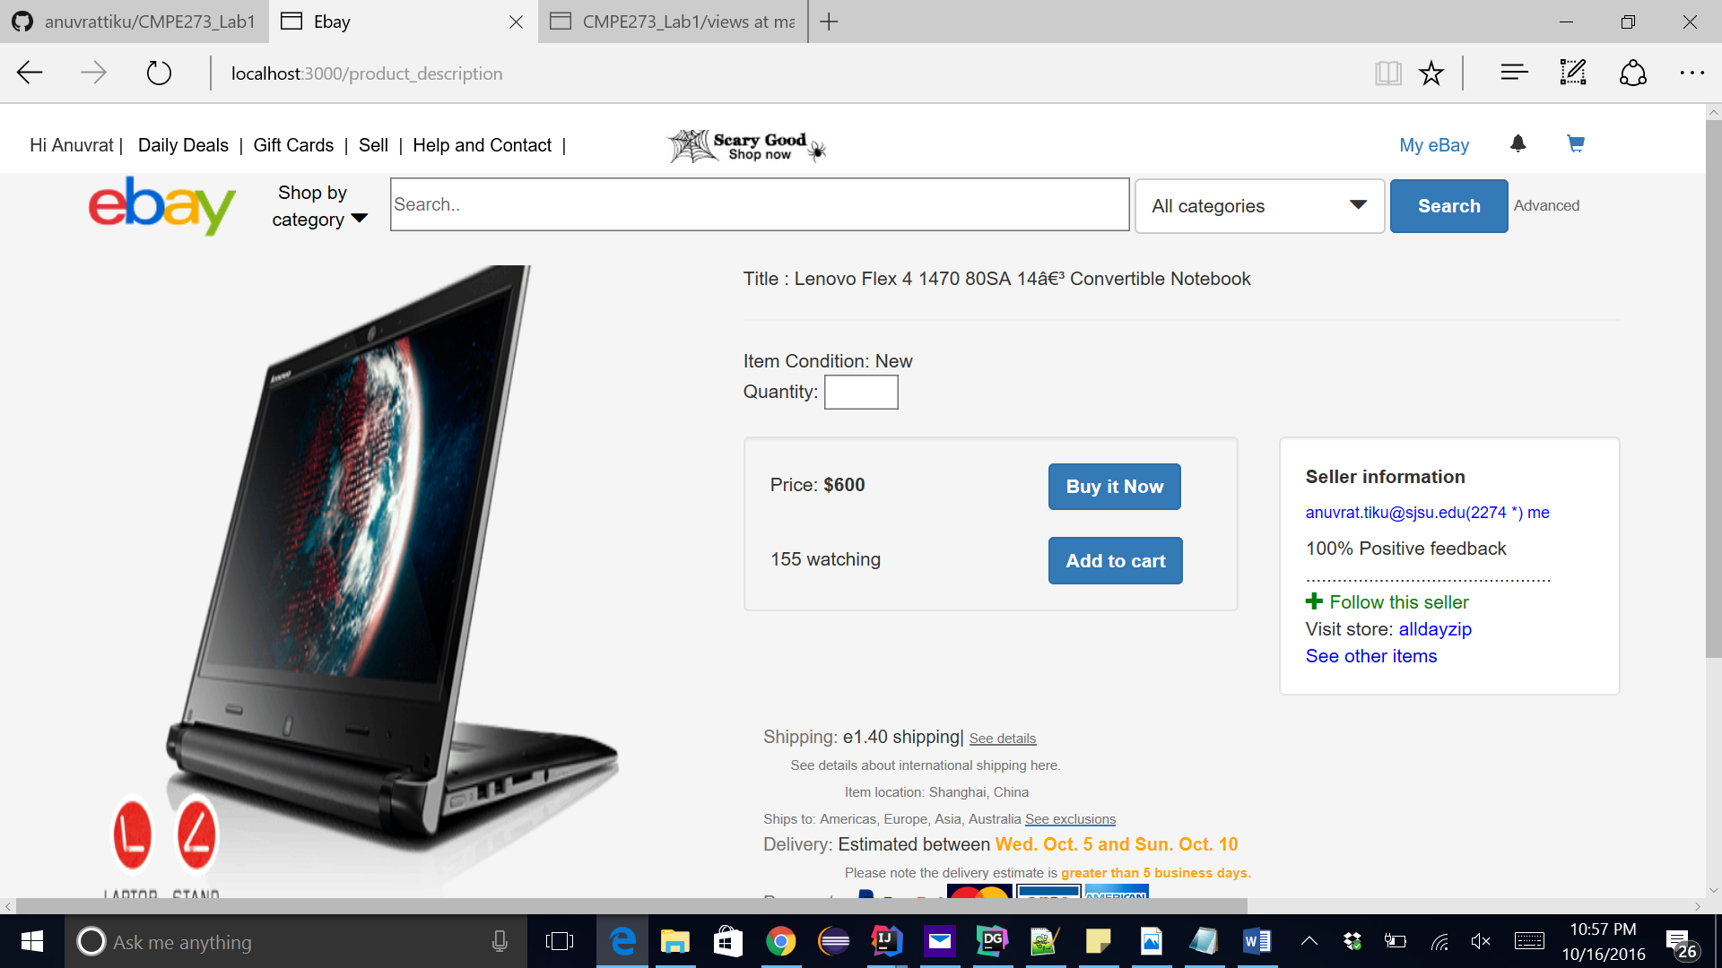

We will order 10 of these laptops but we have only 5 in stock.  
Entering 10 will show an error message to the user to reduce the number of items:



We will enter 3 as the quantity:

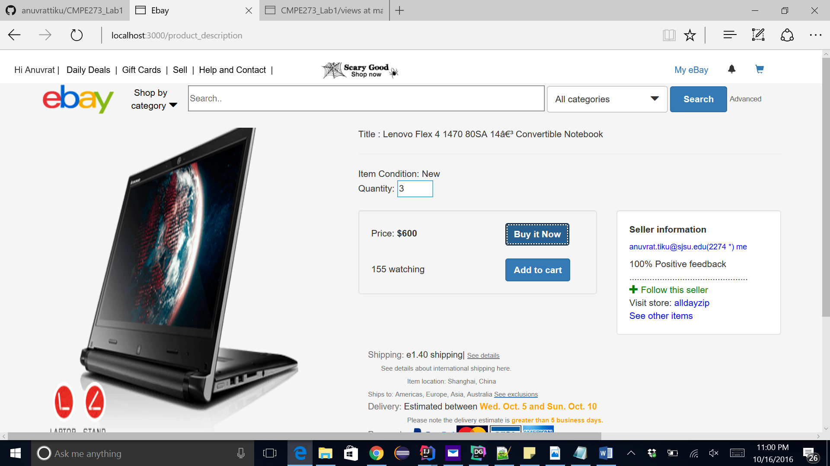

This should not display any error message to the user

Out cart will have 3 products on adding and total will amount to $1800

We will add to cart

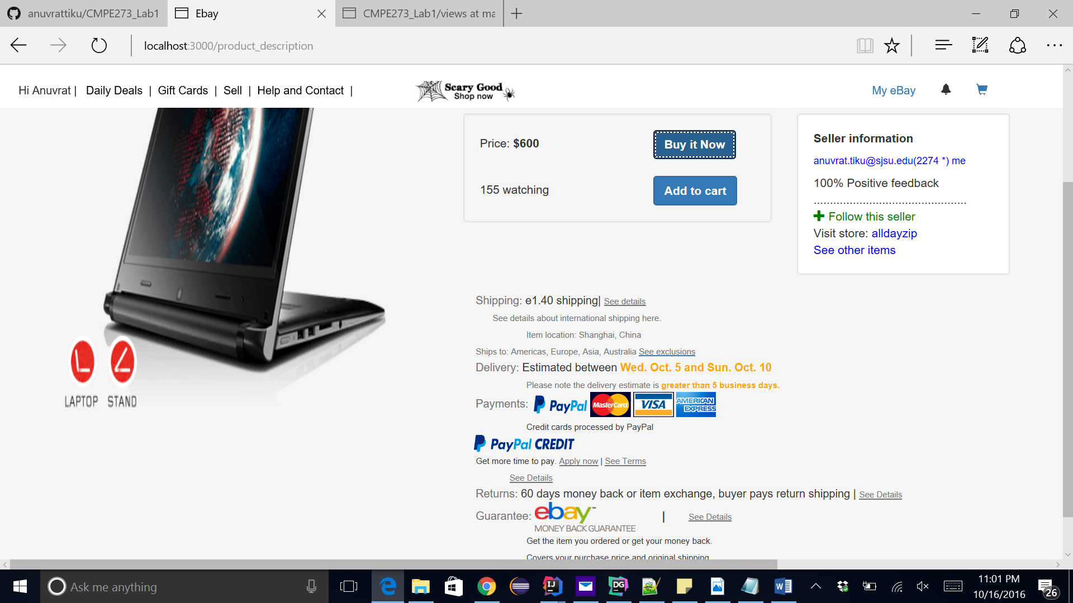

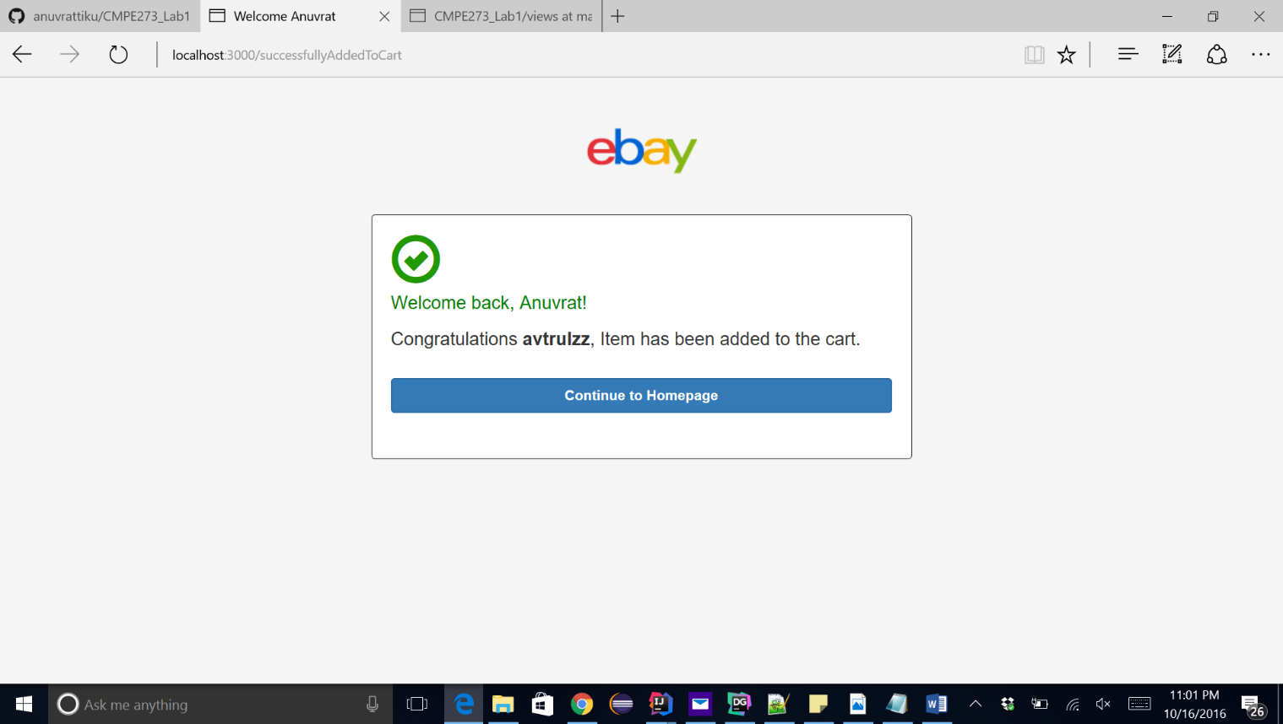

Continue to homepage

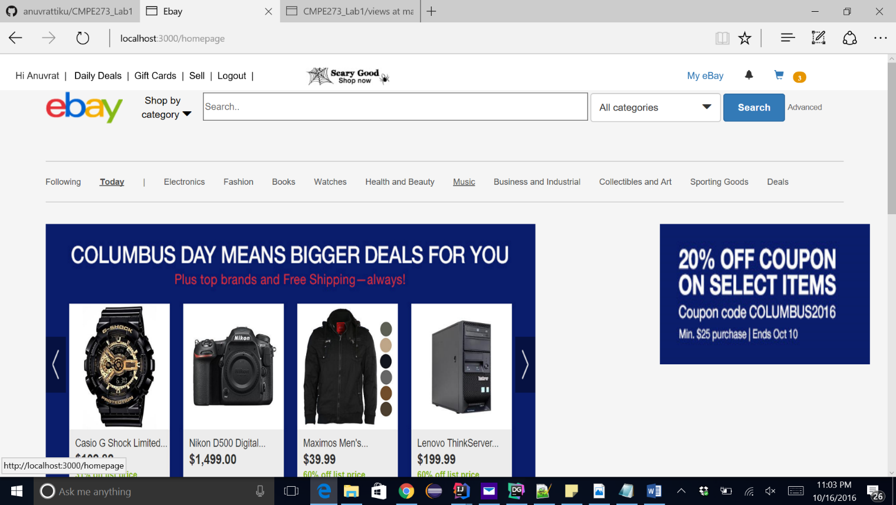

Bootstrap element badge querying the cart database and displaying the total amount of all the elements on screen at the top.

This session cart will be maintained even if the user logs out

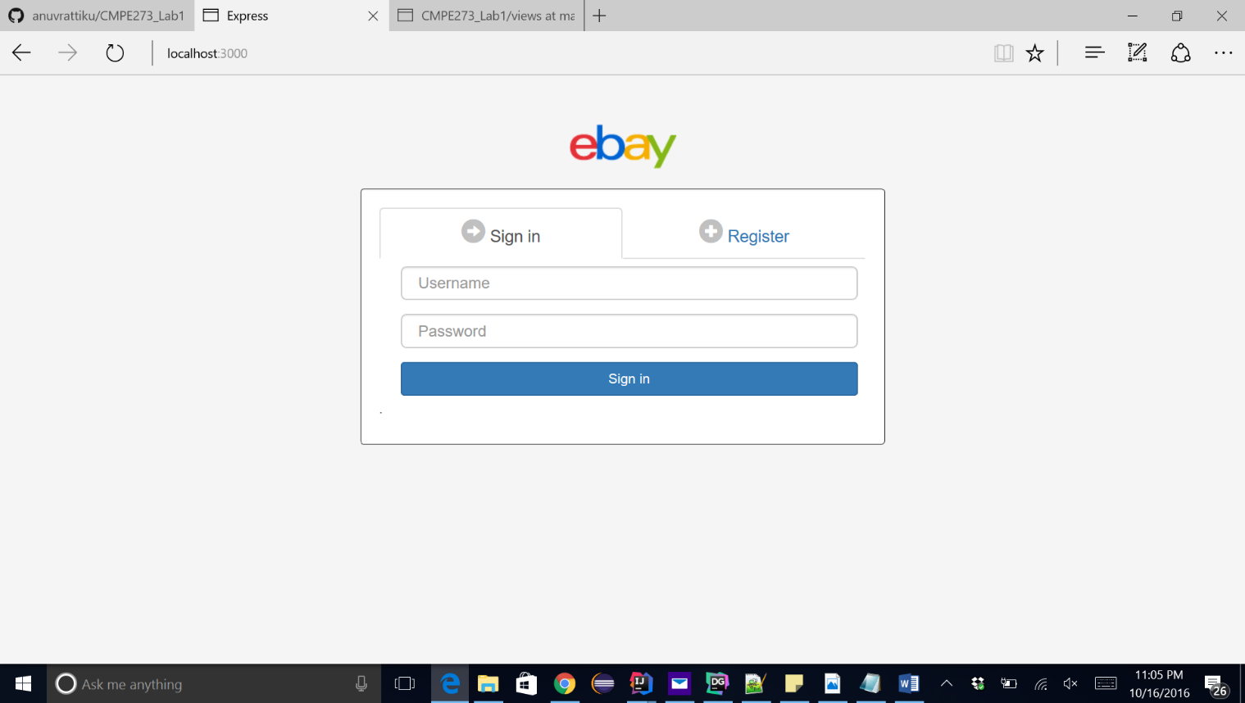

On logging back in user will be able to see the cart

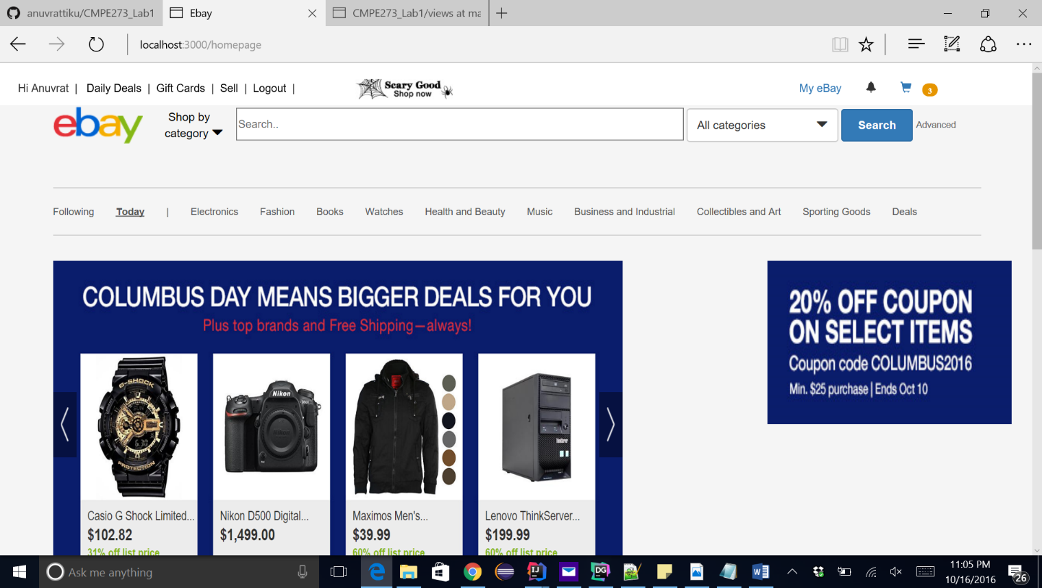

Clicking on the cart icon will give us the items

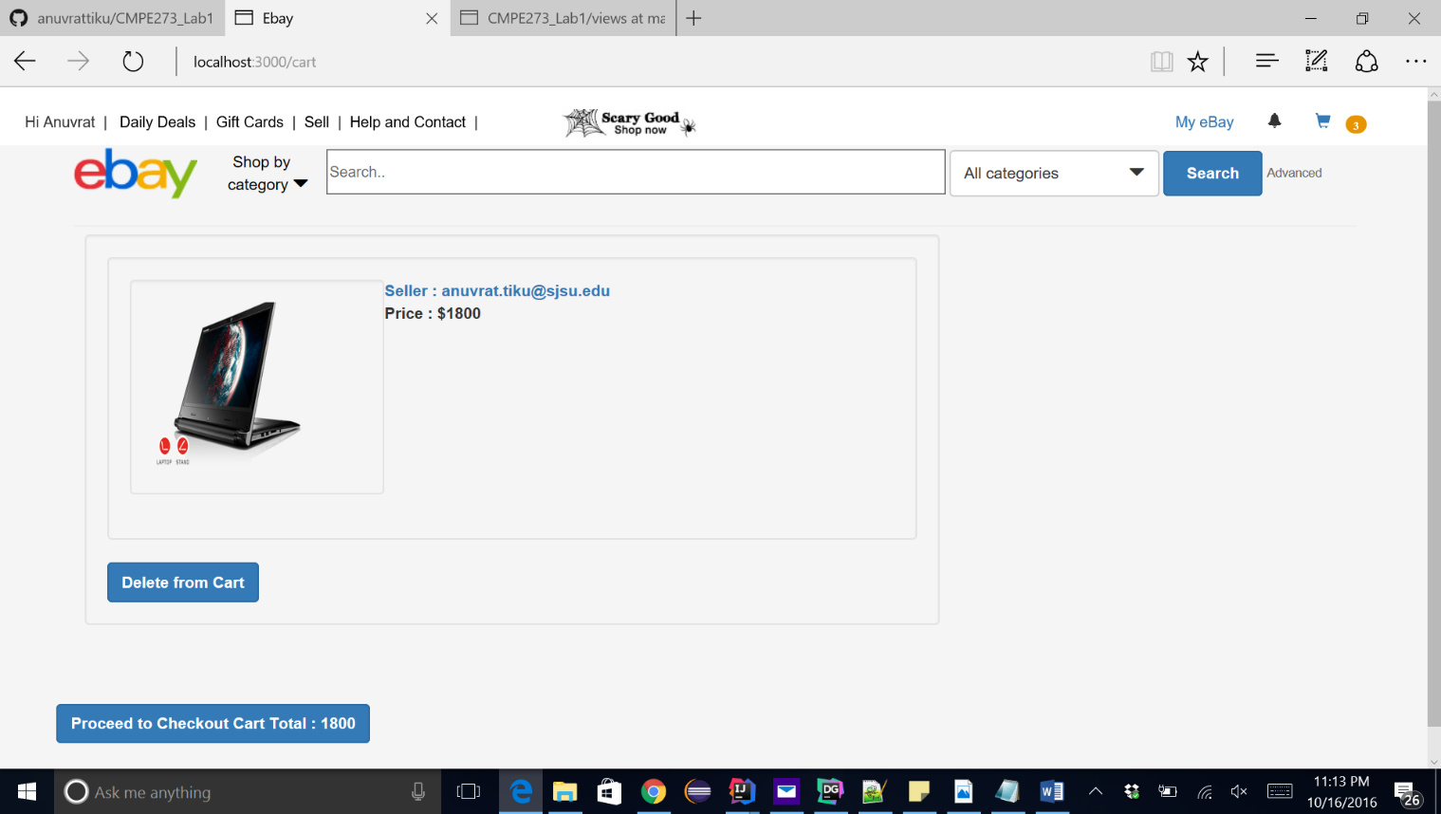

Here we can see the total amount in the cart.

We will go back and add a different item to the cart.

We will add 2 books



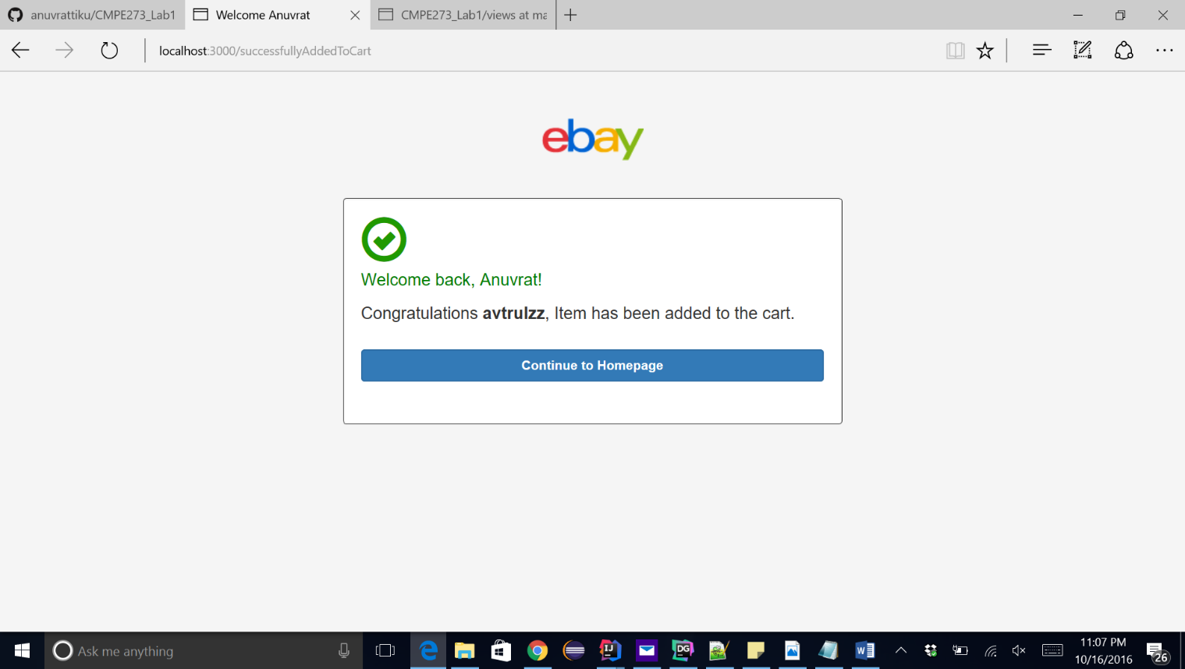

Cart is updated to 5 items

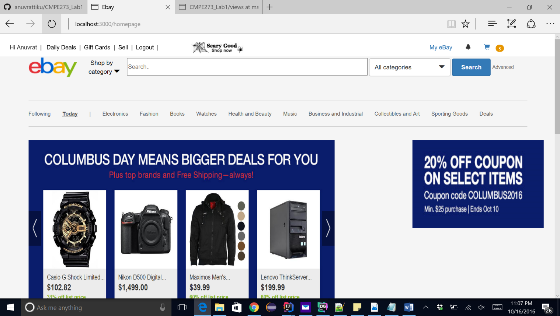

We click on the cart and see the items individual and total breakdown.

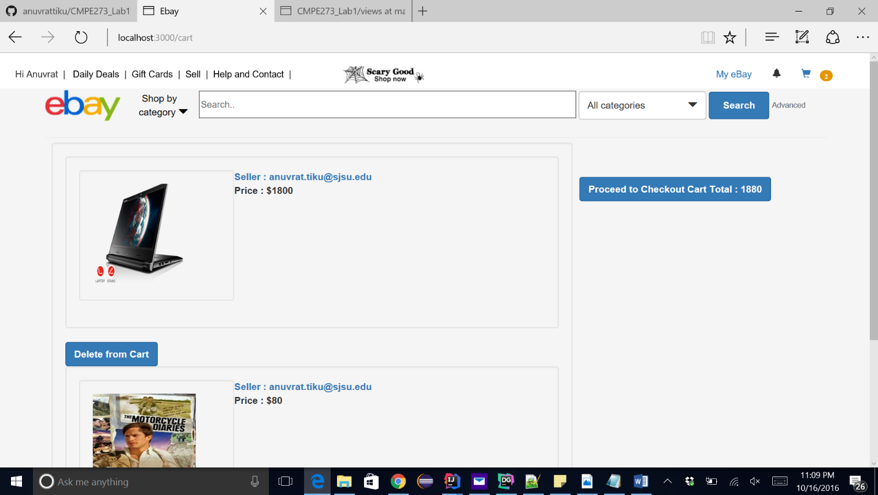

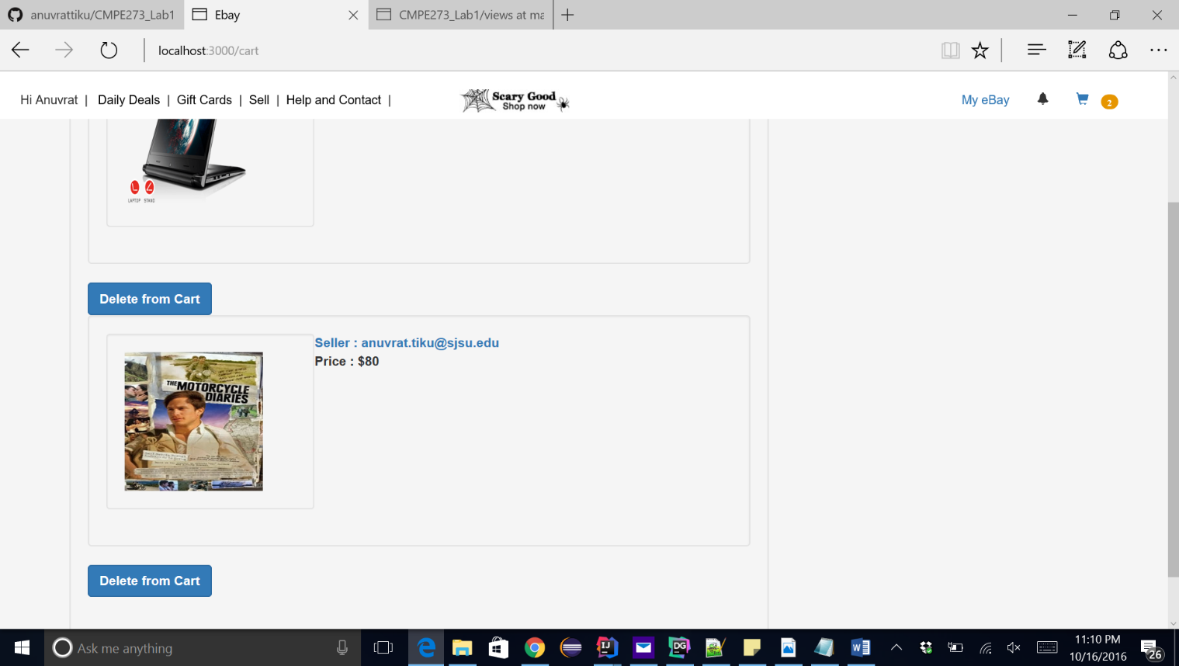

We can also delete an element from the cart by clicking on the delete from cart button

We will delete the Motorcycle diaries book

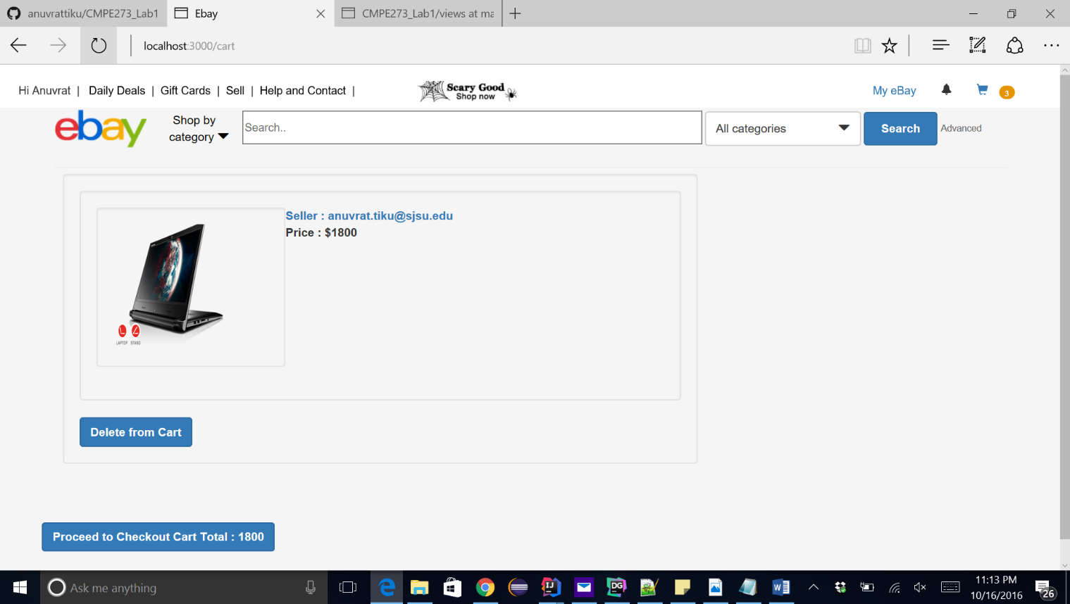

Item is deleted and total price is also updated.

Proceed to checkout

We will be asked for the Card number and other payment details

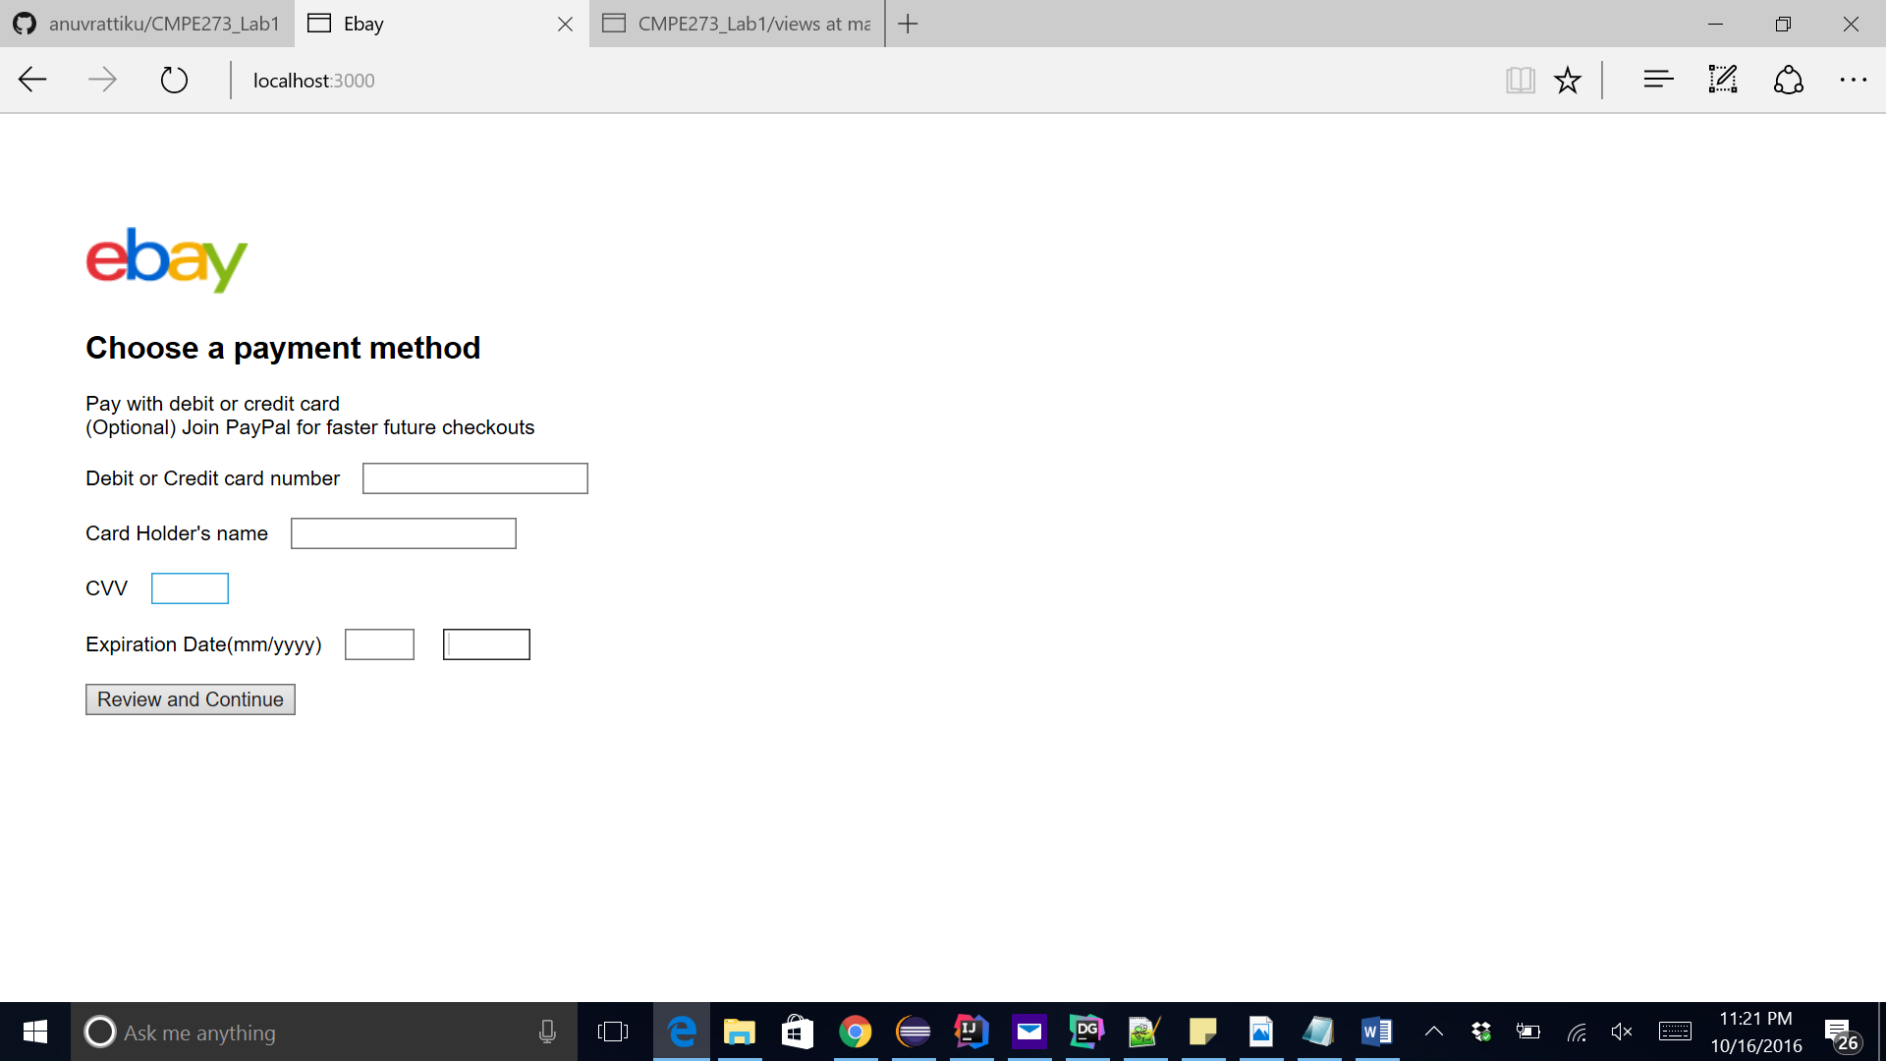

Entering WRONG card details(Only 14 digits not 16)

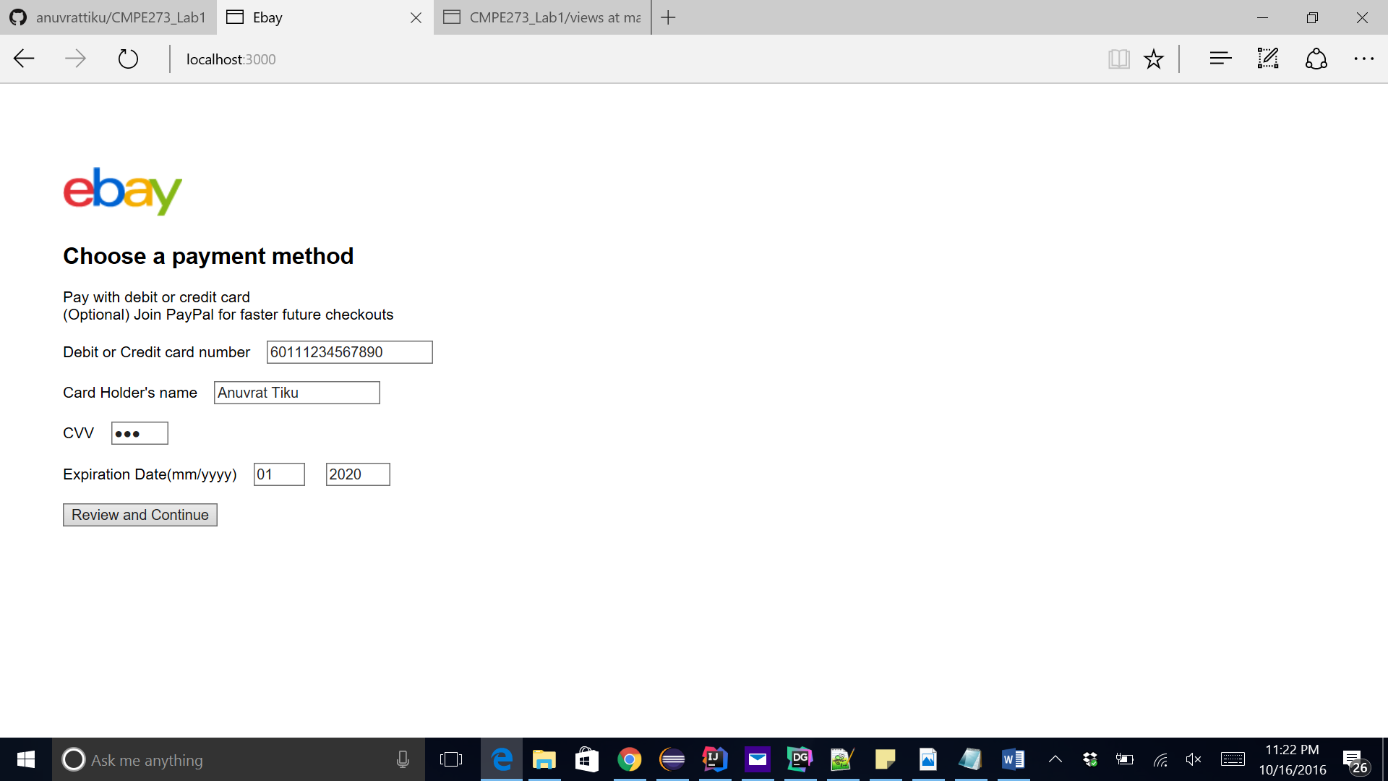

Click on review and continue

Incorrect details and card could not be validated

Your will be given an option to validate his details again

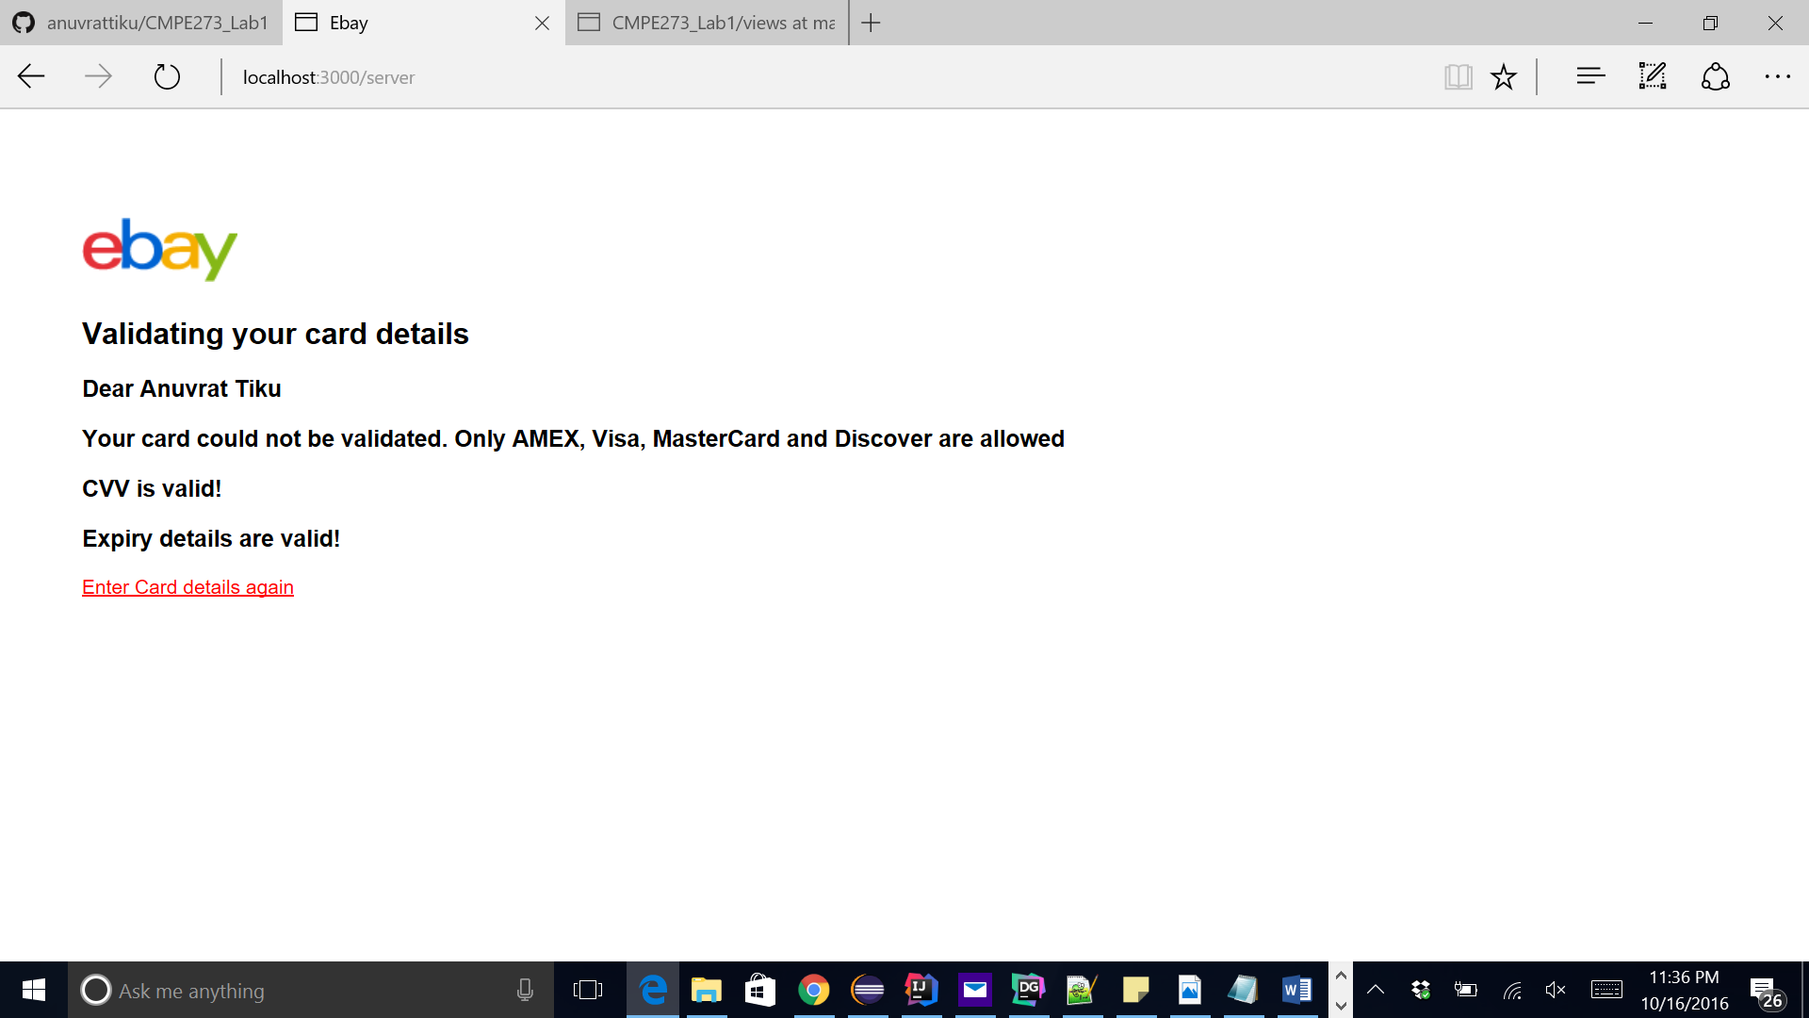

We will go back and enter incorrect details again

This time expiry and CVV will be incorrect

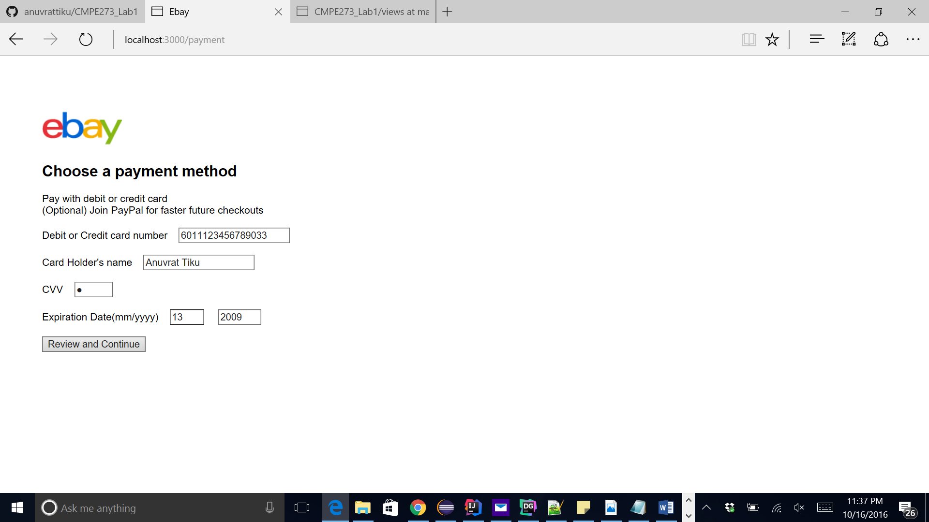



Now finally we will enter correct details



Click on the link to go back to the home page.

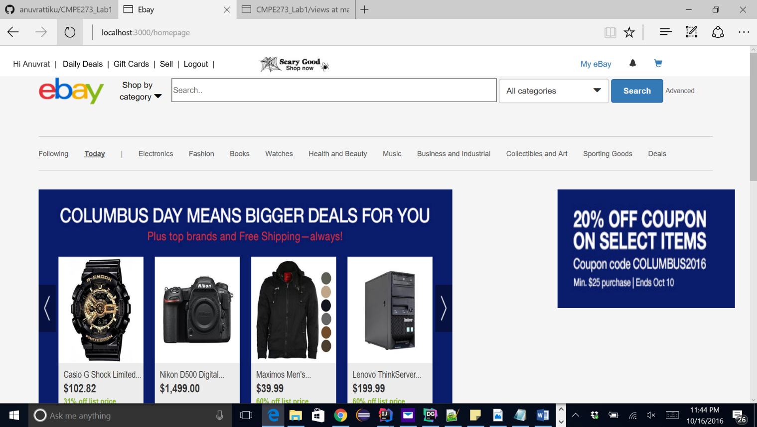

We can see that our cart is empty

Add to cart button is also disabled.

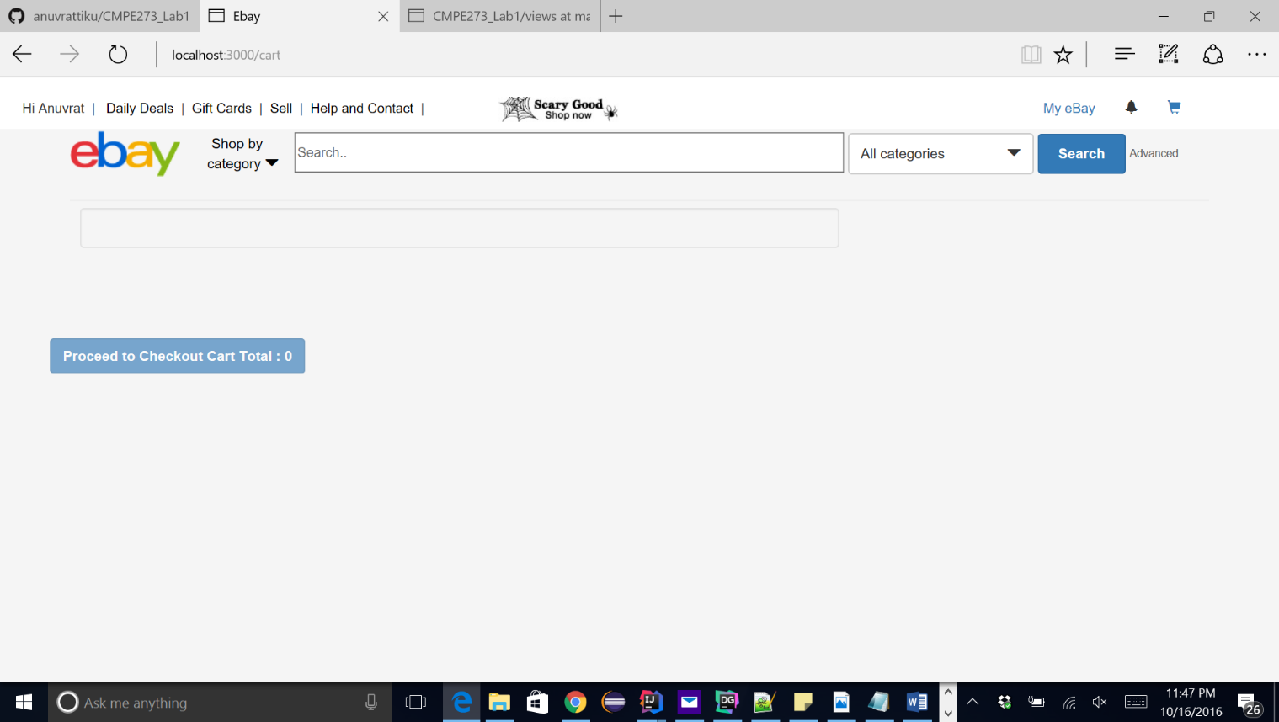

If we go to the orders page, we can see the orders split.

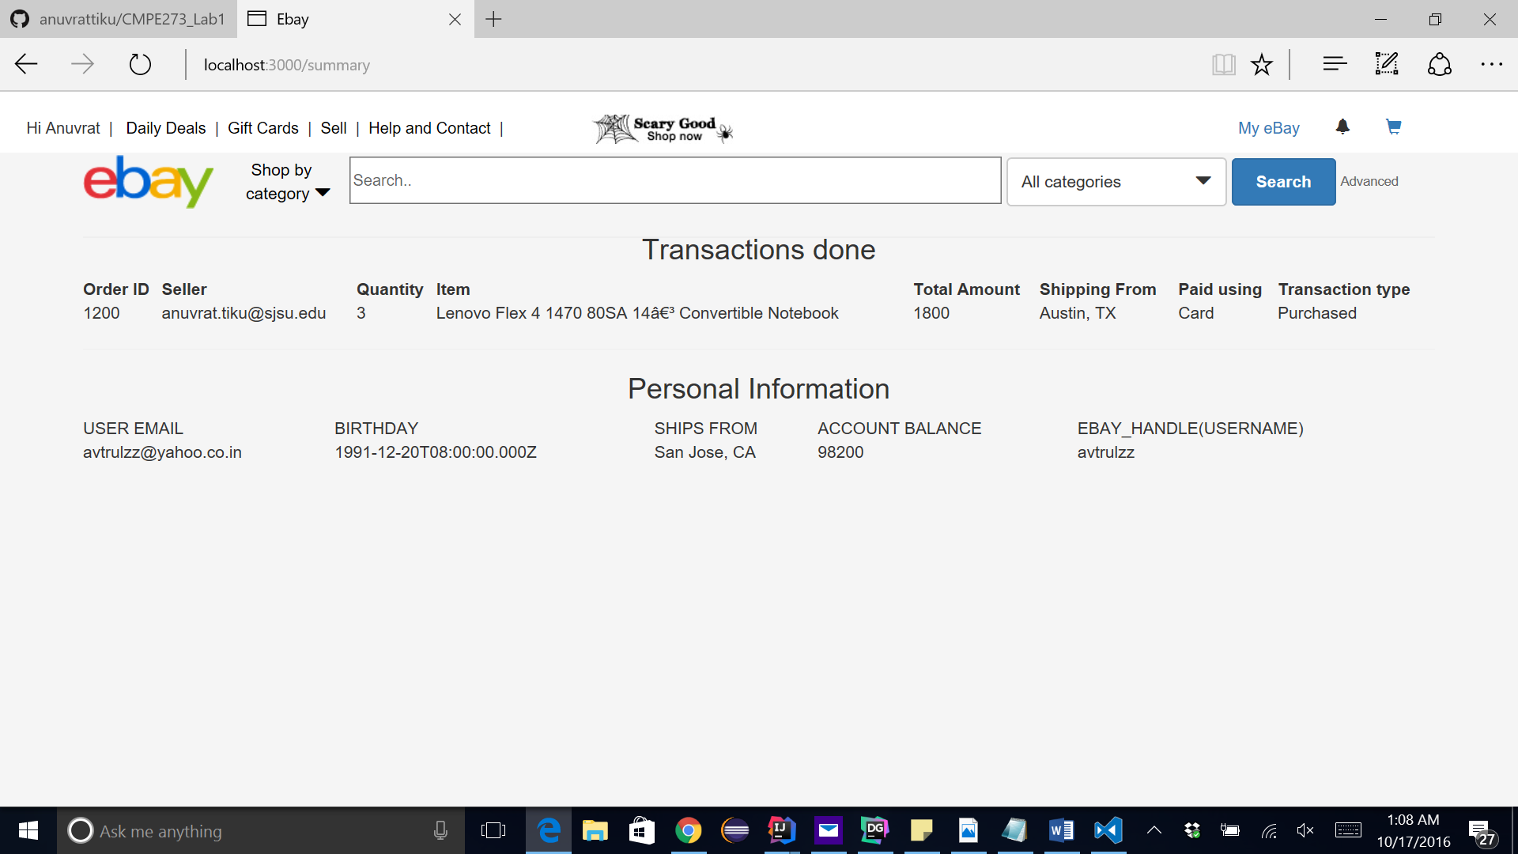

Initial amount assigned to the buyer was 100000 and after paying 1800, he is left with 98200.

We will go into the sellers account and verify his amount, it should be 100000+1800 = 101800 plus an entry with transaction type = sell.

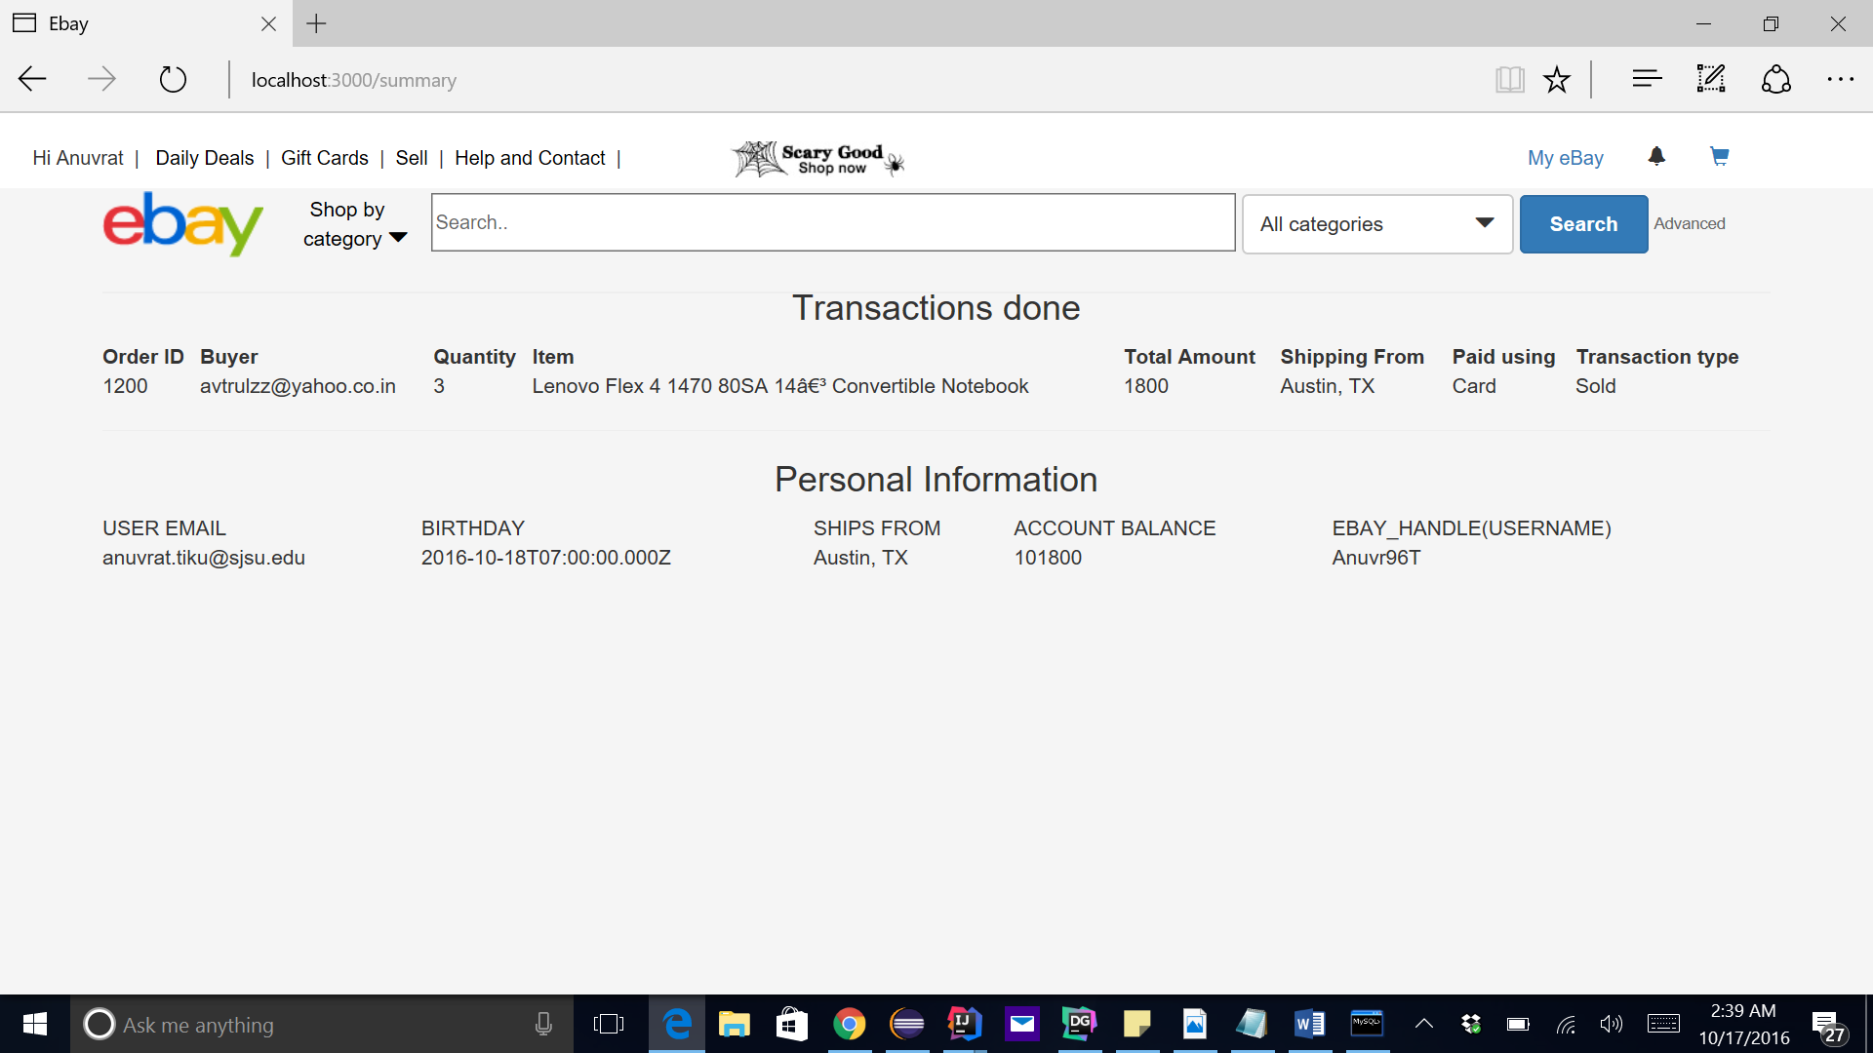

Now we can logout.

It will destroy the session.

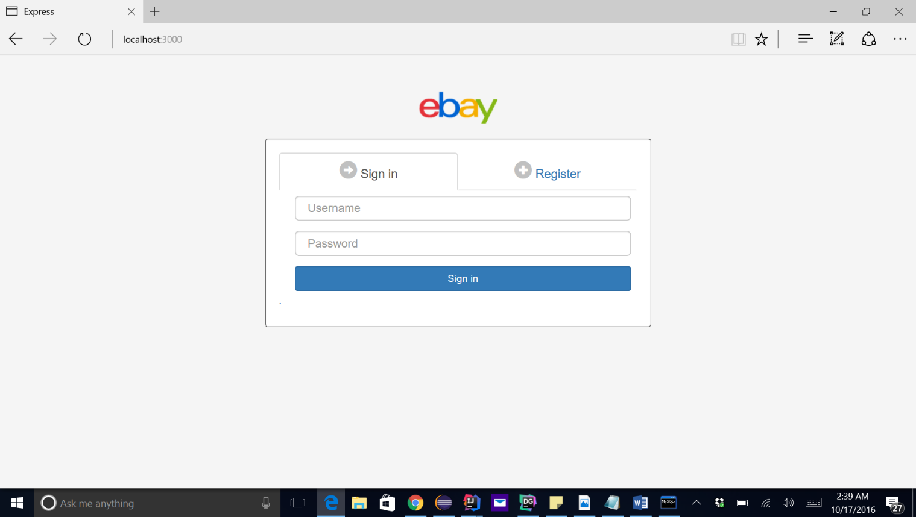

J-meter performance mapping:

100 concurrent users without connection pooling:

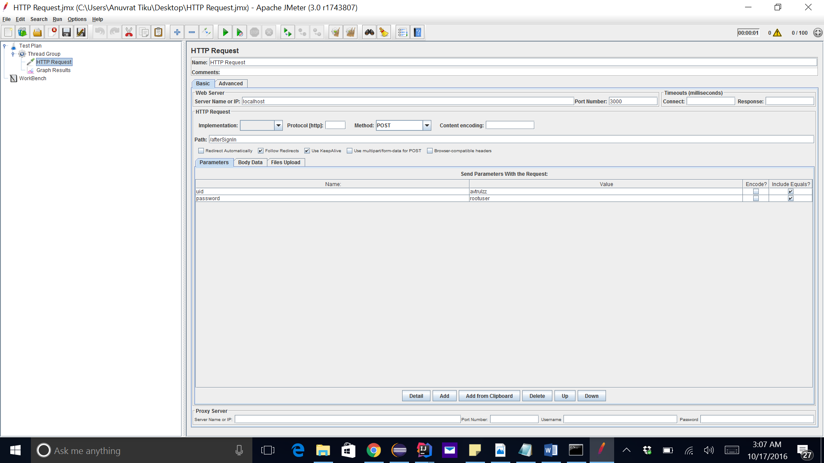

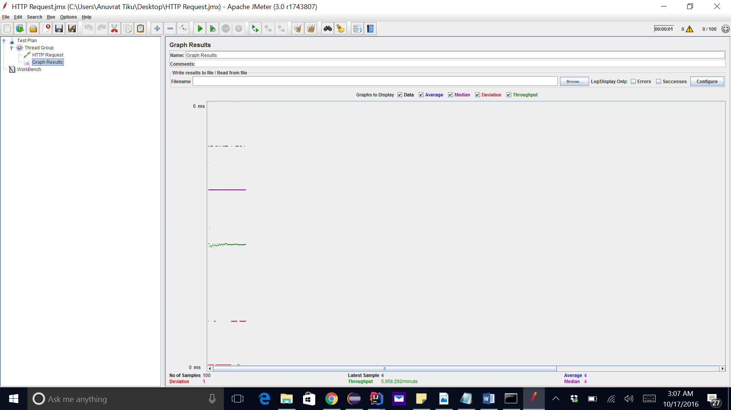

AVERAGE = 4

200 concurrent users without connection pooling :

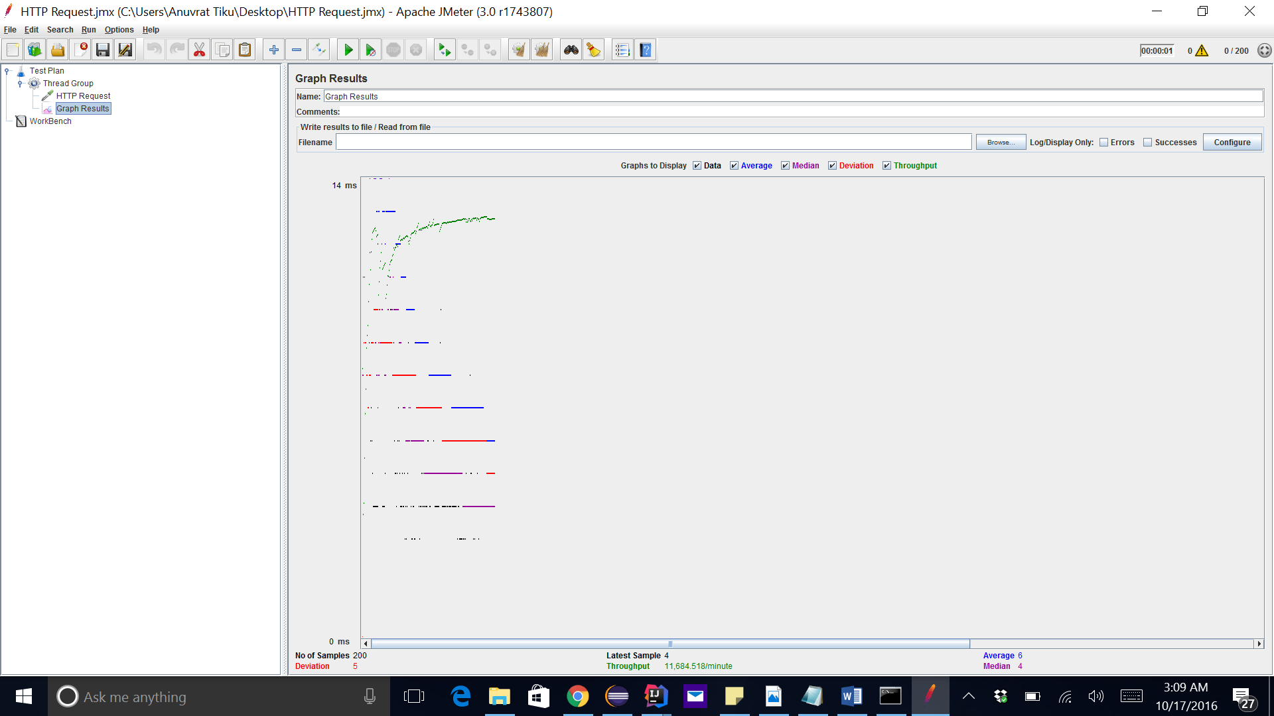

AVERAGE = 6

300 concurrent users without connection pooling :

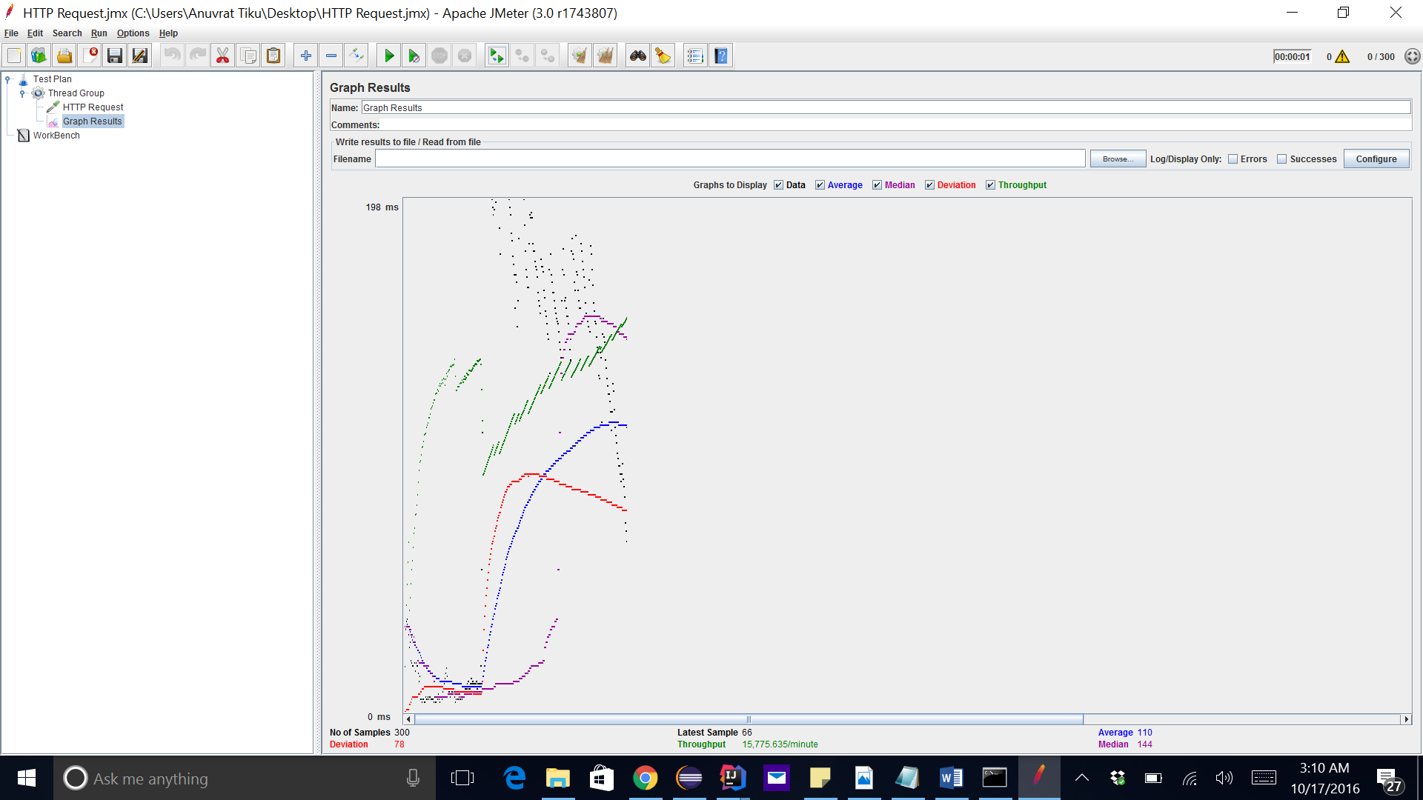

AVERAGE : 110

400 concurrent users without connection pooling :

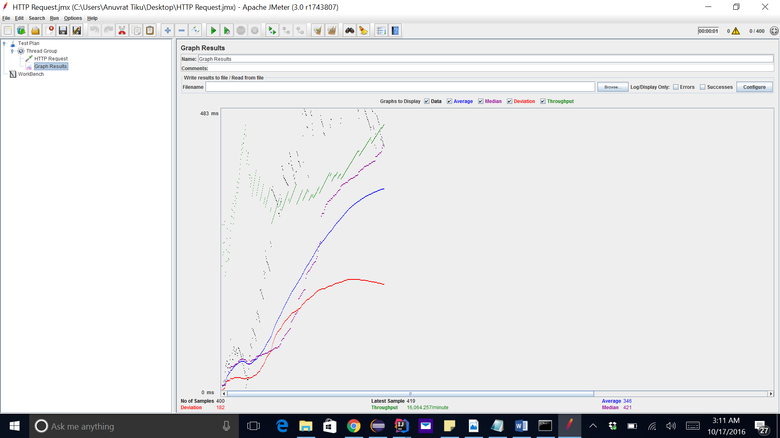

AVERAGE : 345

500 without connection pooling

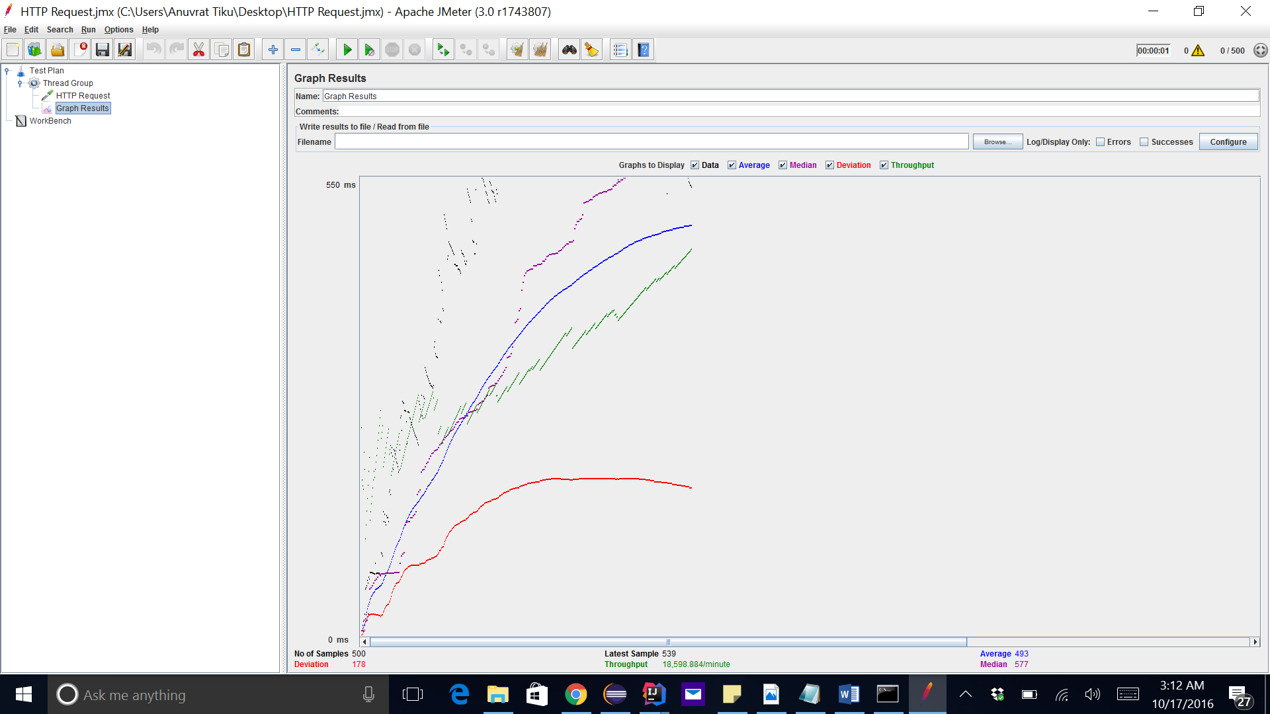

AVERAGE : 493

ADDING CONNECTION POOLING

100 CONNECTIONS

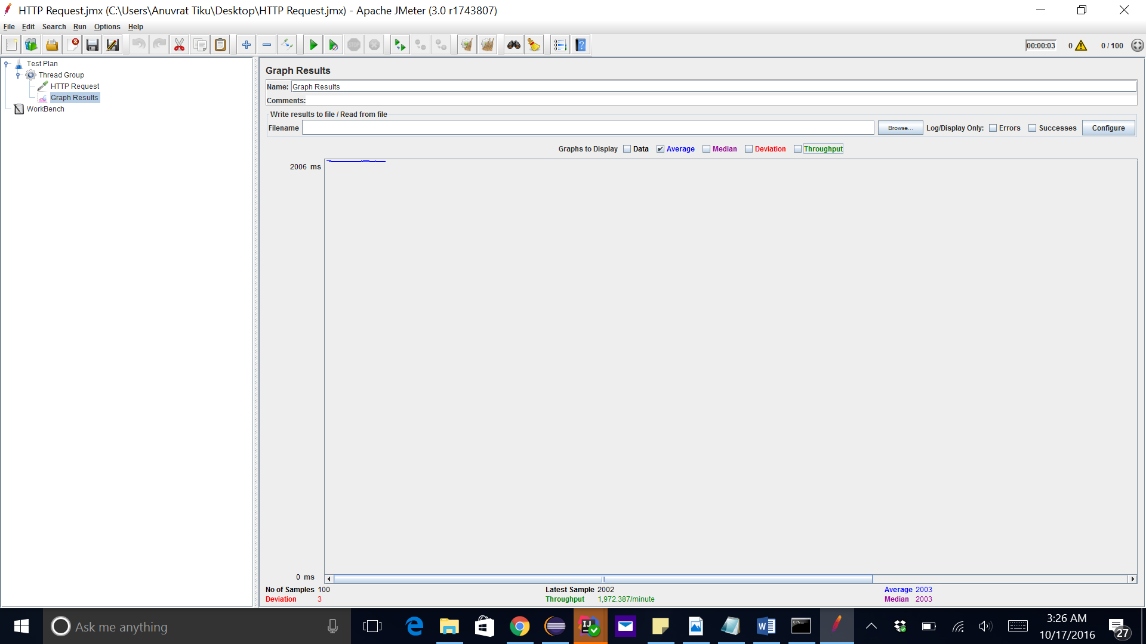

AVERAGE : 2003

200 CALLS

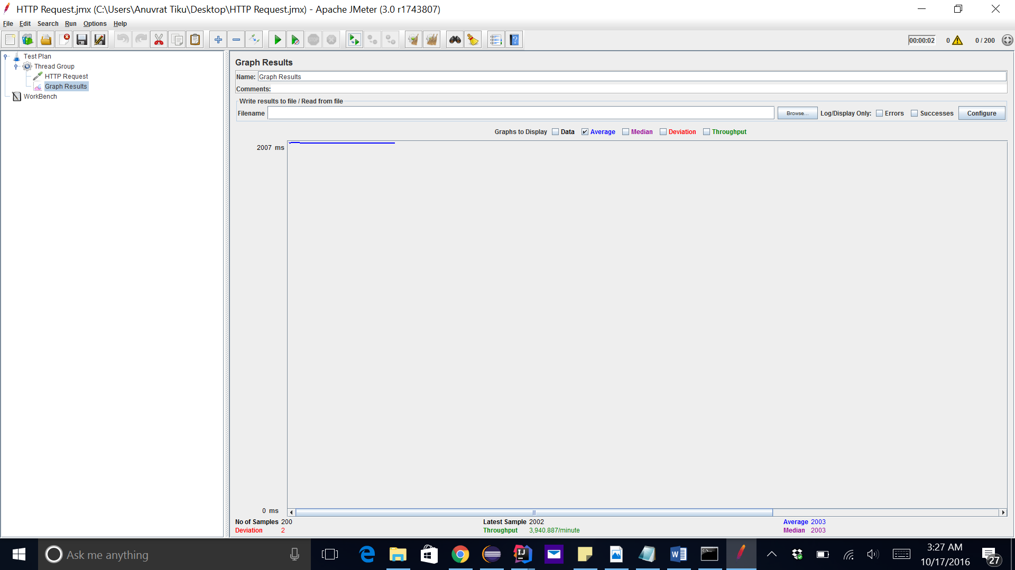

AVERAGE : 2003

300 CONCURRENT CALLS

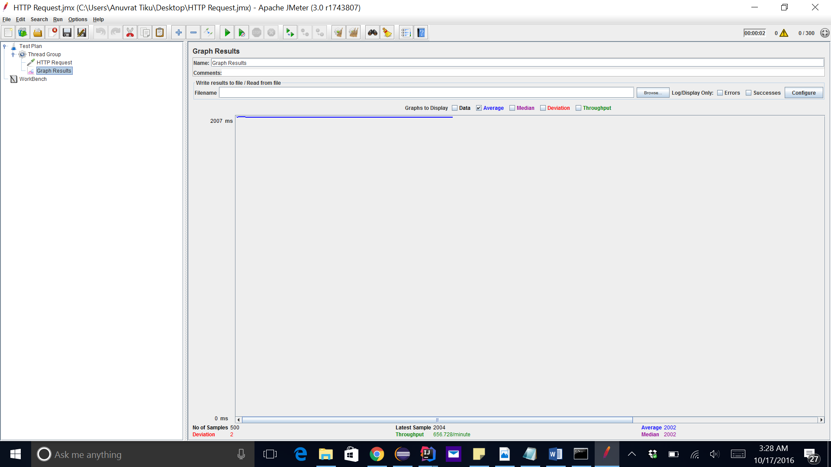

400 CONCURRENT CALLS

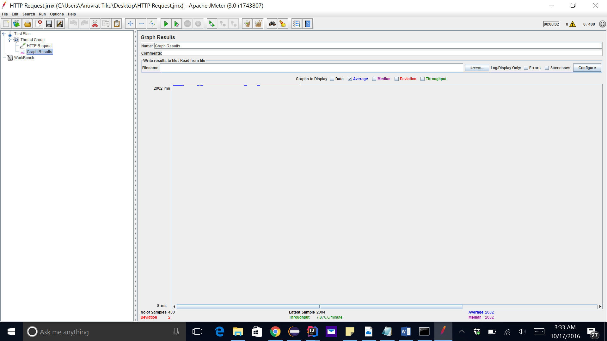

AVERAGE : 2003

500 CONCURRENT CALLS

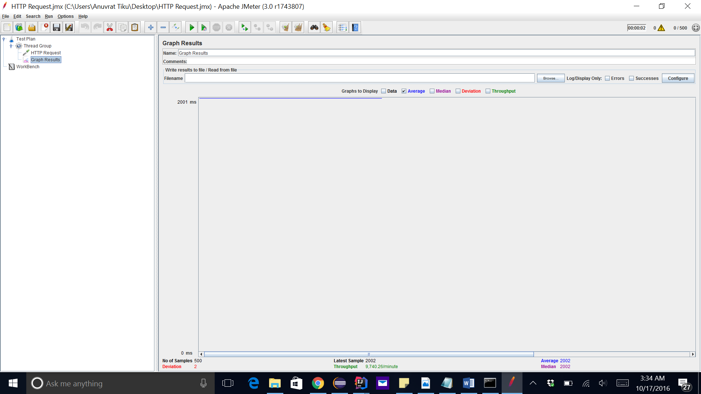

AVERAGE : 2003

CONNECTION POOLING COMPARISION

**Q3 – QUESITIONS**

**PART 2**

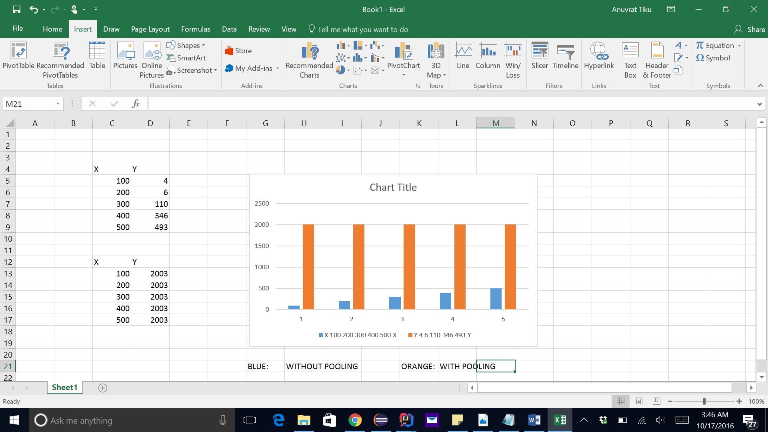

CONNECTION POOLING ALGORITHM :

We are taking a stack of 50 connections so at one time 50 concurrent users can login to application. Any new connection can be added to the stack and once any of the connection is released the connection can be popped out from the stack. Each connection is made during querying mysql database and as soon as database has been queried connection is released.

exports.createConnectionPool= **function** createConnectionPool(){  
 **for**(**var** i=0; i<poolS;i++){  
 pool.push(getConnection());  
 }  
  
}

Analysis of graphs :

When not using connection pooling, the performance for lesser numbers of connection is less and the average goes up as the number of concurrent users(threads) go up. We can see that 100 users average is 4 but as the number goes up to 500, the average also goes up to 493.

When using connection pooling, the average is poor for small number of connection because of concurrent connections but as the connection number goes up, performance is steady and does not decrement. We can see that the performance is 2003 for 100, 200, 300, 400 and 500 concurrent requests.

**QUESTION 3 PART 1**

We have implemented the AES which stands for Advance Encryption standard for the purpose of the encryption. The encryption with AES is done with the help of three different key lengths -128, 192 and 256. We are using 256 bit of the key size for our encryption algorithm. This AES belongs to the Rajndael family which has a fixed block size of 128 bits. The number of the transformation round specifies the encryption technique for the input text which is being converted to the ciphertext. AES does not support Fiestel nework DES (Data Encryption Standard) as its predecessors used to support. AES is based on the principle of substitution and permutation network which is a both fast and reliable on both hardwares and softwares.

The key size used for AES encryption decides the number of repetitions of transformation rounds and the number of cycles repetition for different keys are 10 for 128-bit, 12 for 192 and 14 for 256.

Along with the encryption there is CTR (counter) which is used for control mode. CTR does not use traditional IV method but make use of the counter to implement encryption.

CTR is much better than CBC mode because it provides both encryption and decryption in parallel rather than CBC.

AES-256-CTR is easier to decrypt

There is no randomness

Less logic is required and no padding and overhead.

There is less latency as the key stream is recalculated.

**QUESTION 3 PART 3**

SQL request caching is caching the SQL query statement along with its result. Server will have to respond for each query from client but when there are similar queries server will return the result from query cache rather than executing same query again and again. As read and write operations are performed continuously, the query cache will be useful in case when number of read operations are more than write operation therefore operation such as retrieval of data from database will be performed efficiently and fast. On the other hand, query cache is not suited for insert, update, delete operations.

On modification of data in database, data in query cache are emptied. Steps to implement SQL query cache in MySQL as follows:

Add configuration directives to the MySQL server as follows: query_cache_size = SIZE (Allocation of memory for caching results). query_cache_type = OPTION (With three options)

1. Option 0: No cahing.

2. Option 1: Cache query results except those that start with SELECT S_NO_CACHE.

3. Option 2: Cache query results that begin with SELECT SQL_CACHE. Add the configuration directives to the MySQL server,

query_cache_size = 50;

query_cache_type = 2;

Example:­"SELECT SQL_CACHE * FROM tabletype;"

**Mocha Testing for Ebay : 5 random REST API calls**

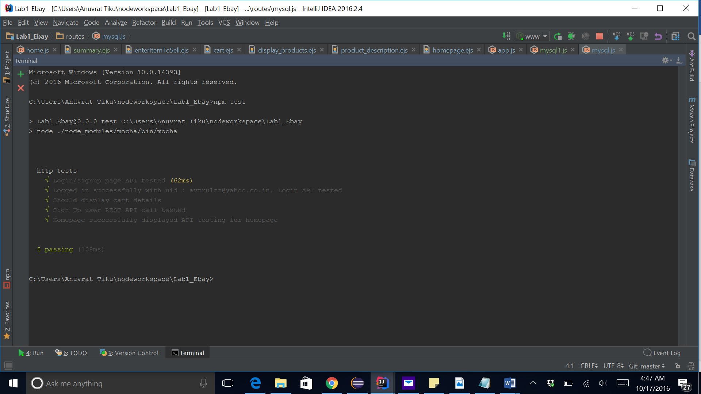

**1. Calculator**

**1 .1 Introduction:**

Calculator is a simple app which is built by using the NodeJs, AngularJs and HTML5. The HTML 5 makes the front end of the calculator where the user can put his input and

Angular provides a MVC architecture. The calculator can perform the following operations like Addition, Multiplication, Division and Subtraction. The input to the calculator can be numbers only and this has been taken care with the HTML. The other important validation is that division by zero. If the user tries to divide a number with zero then it should return as error message as division by zero not possible.

The user can enter any valid number i.e 0-9. If user inputs any alphabet then it should throw an error. User cannot leave any of the text boxes as blank.

**1.2 System Design:**

The calculator app makes use of the Front end as HTML 5 , angularjs and CSS. The DOM would collect the information (Number1 and 2 ) entered by the user and take it to the server and perform the set of the calculations as per the logic designed by the user. There are buttons on the screen on which the user can chose the set of operations which varies from Addition, Subtraction, division and Multiplication.

Backend of the calculator is a NodeJs application and that’s where the actual calculation is performed. The data received from the frontend is processed as per logics. The data is sent from the frontend using the http requests. Responses is sent from the backend to the frontend to display the outputs.

1.3 Result

1. Adding two numbers:

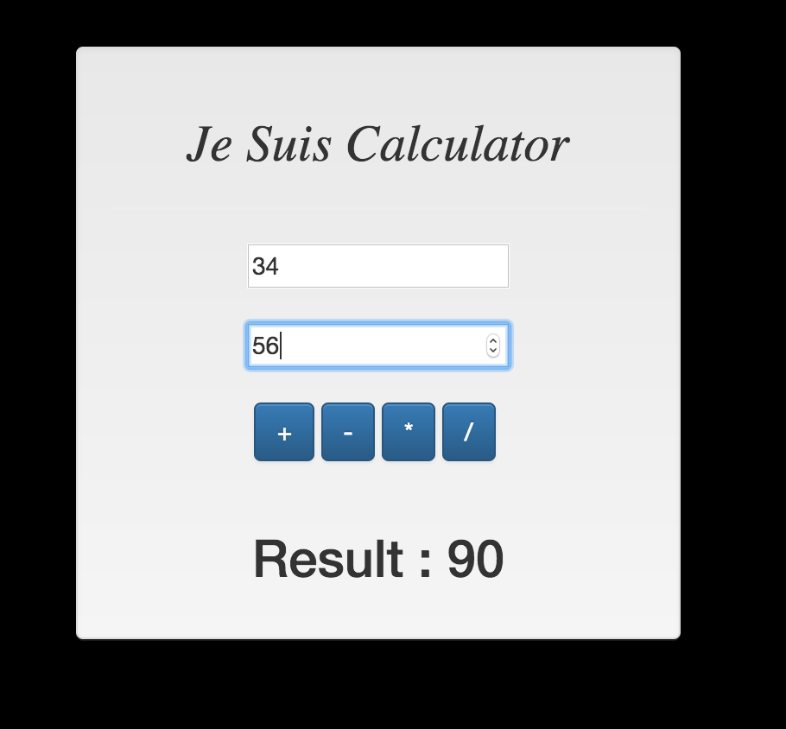

2. Subtracting two numbers

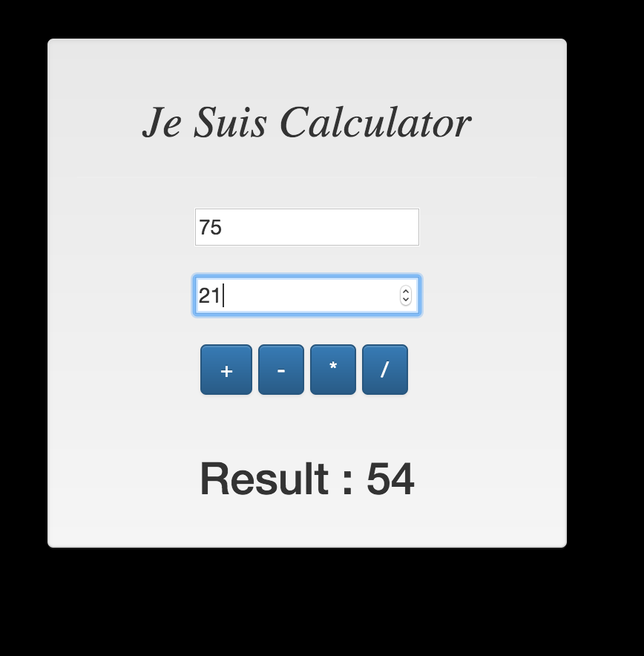

3. Multiplying two numbers

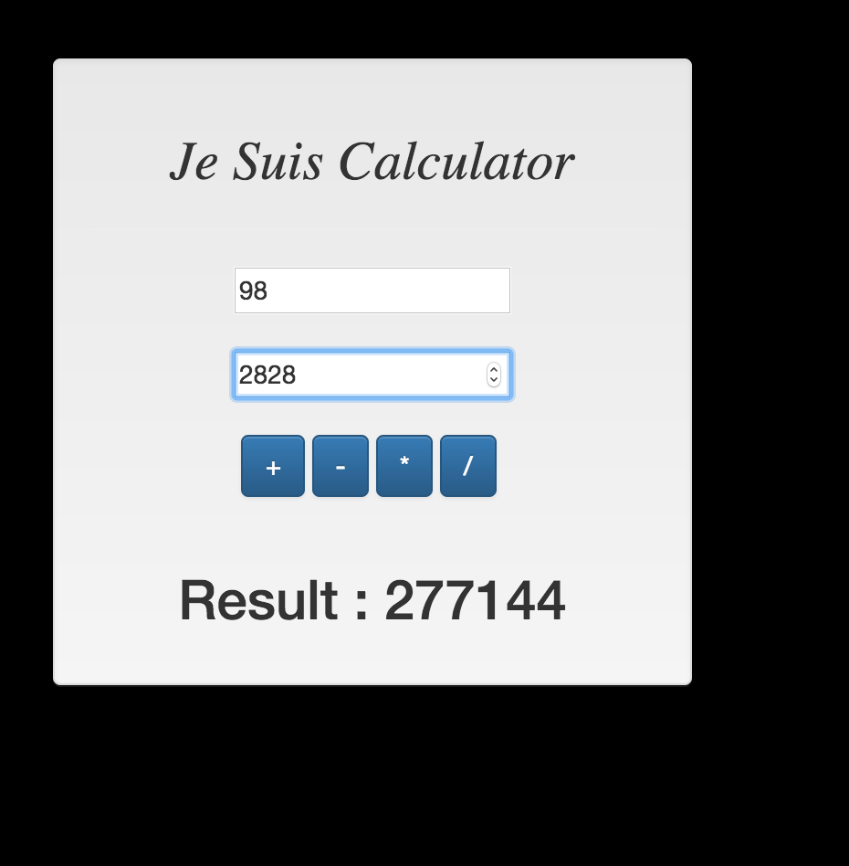

4. Dividing two numbers:

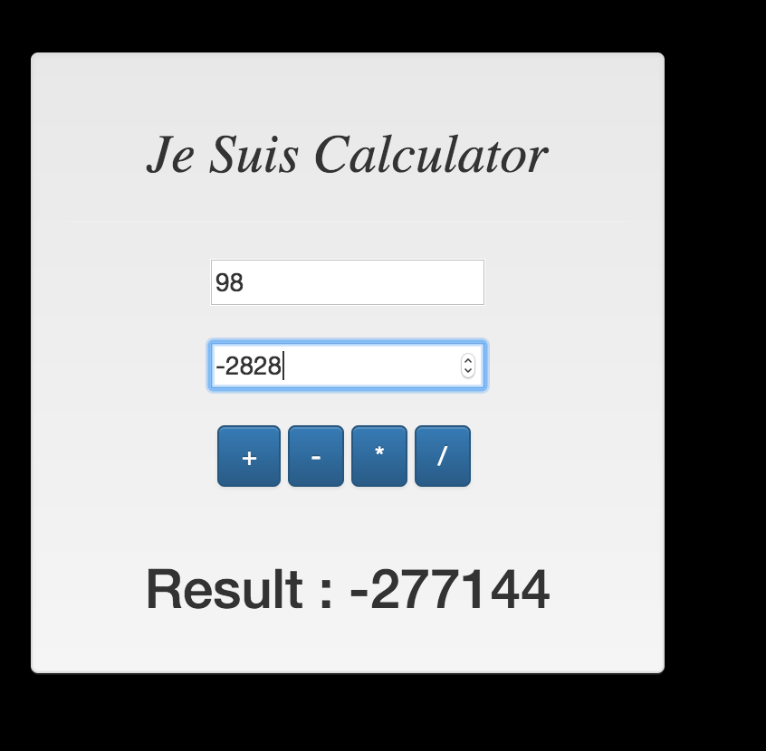

5. Dividing two numbers where second is zero – As expected it threw an error that Cannot divide by 0.

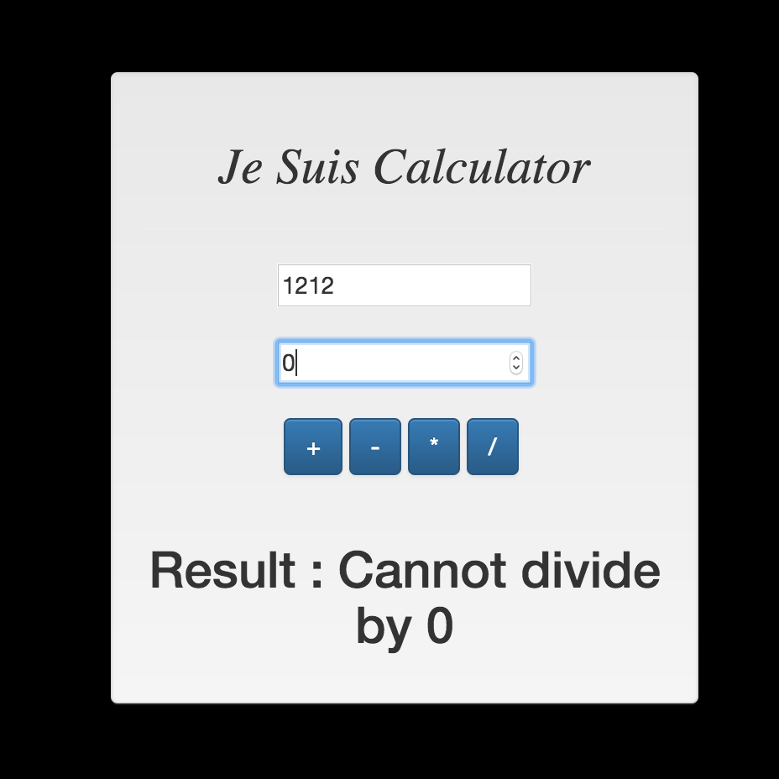

Calculator J-meter testing

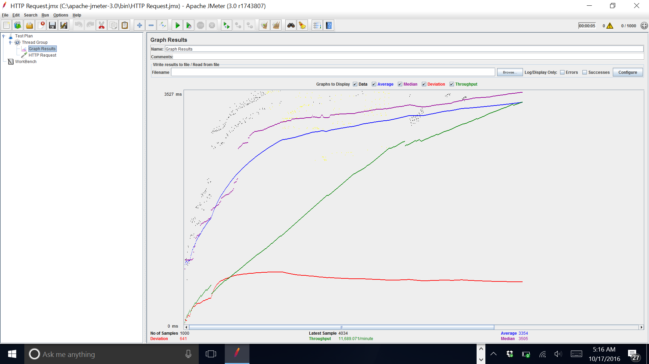

Average

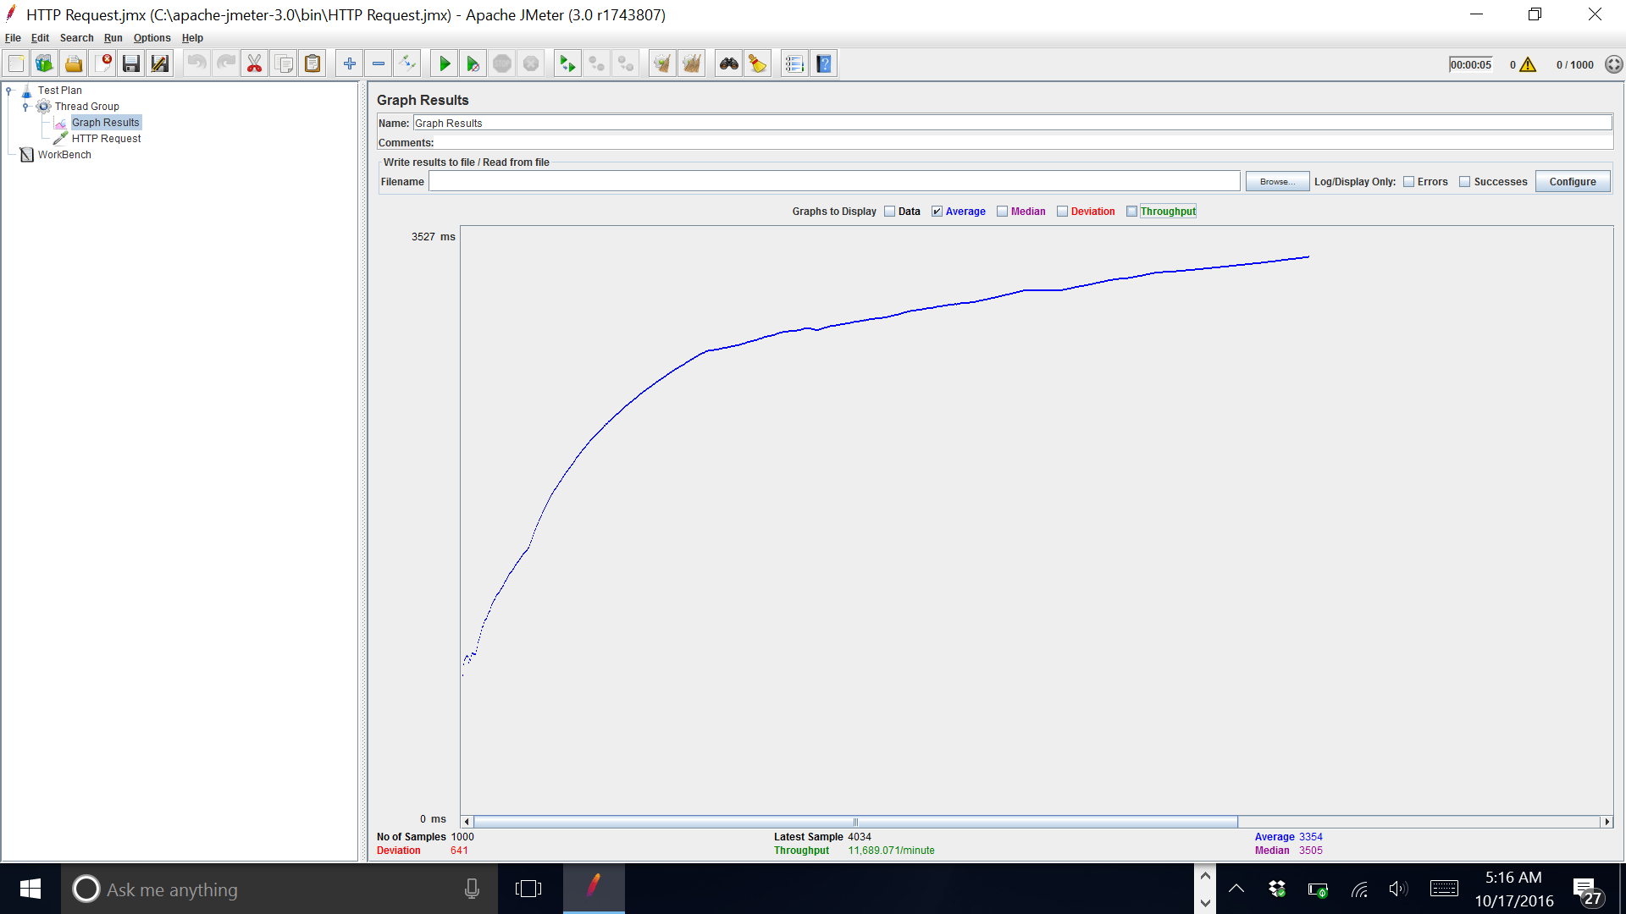

5000 calls to the calculator

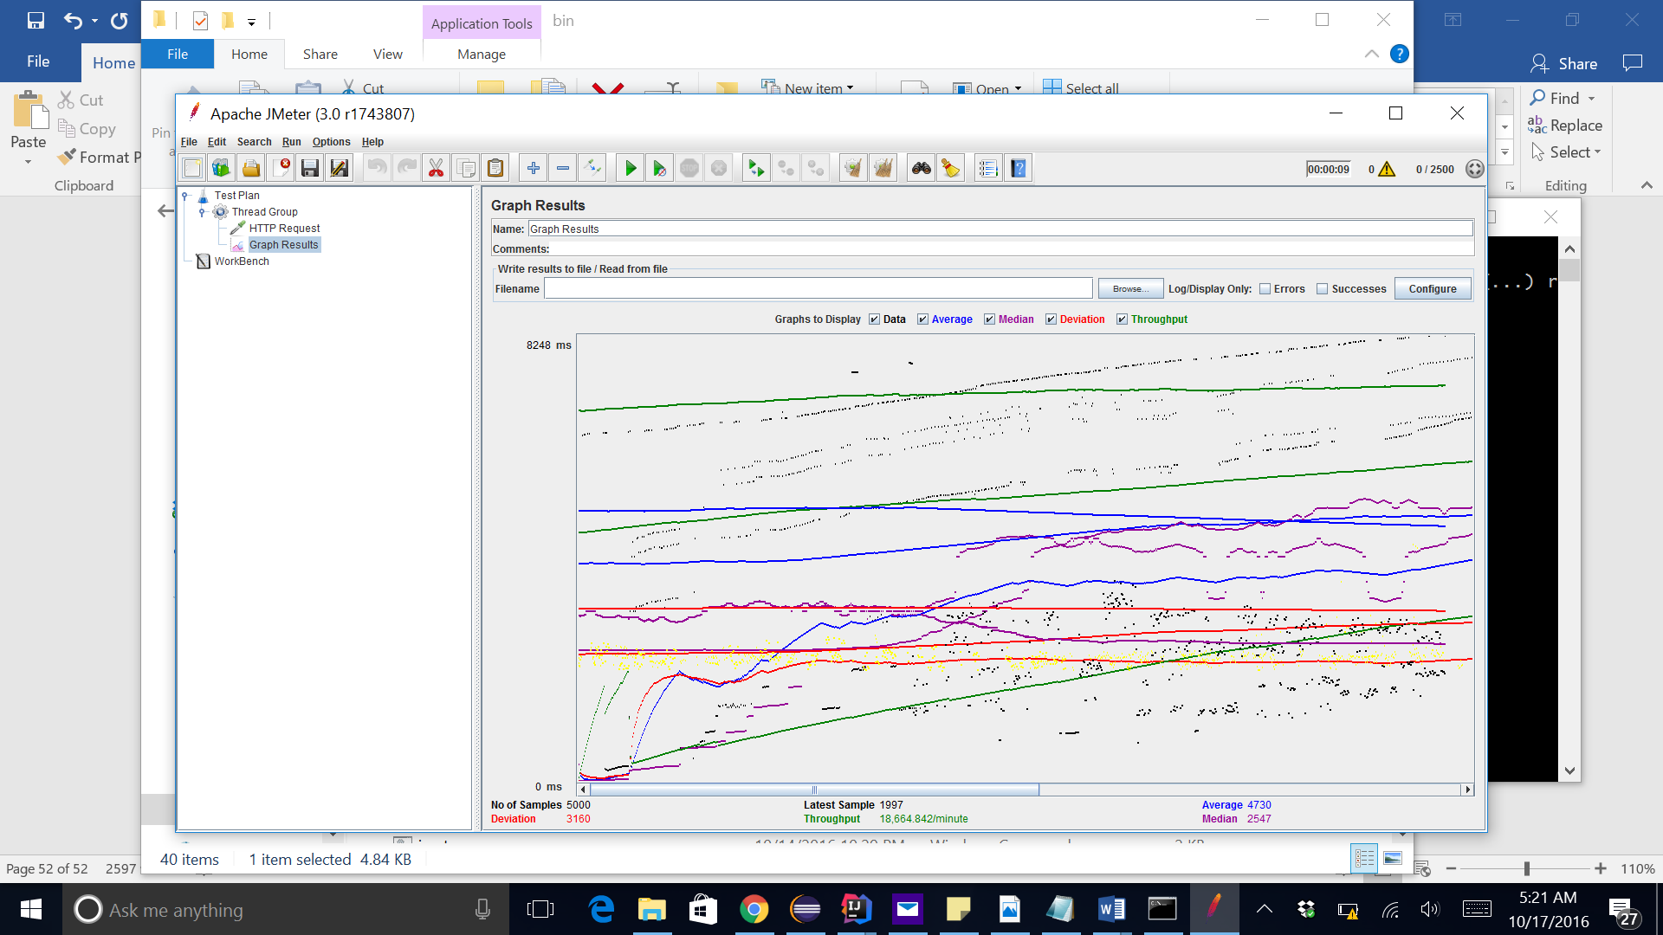

100 concurrent 1000 requests

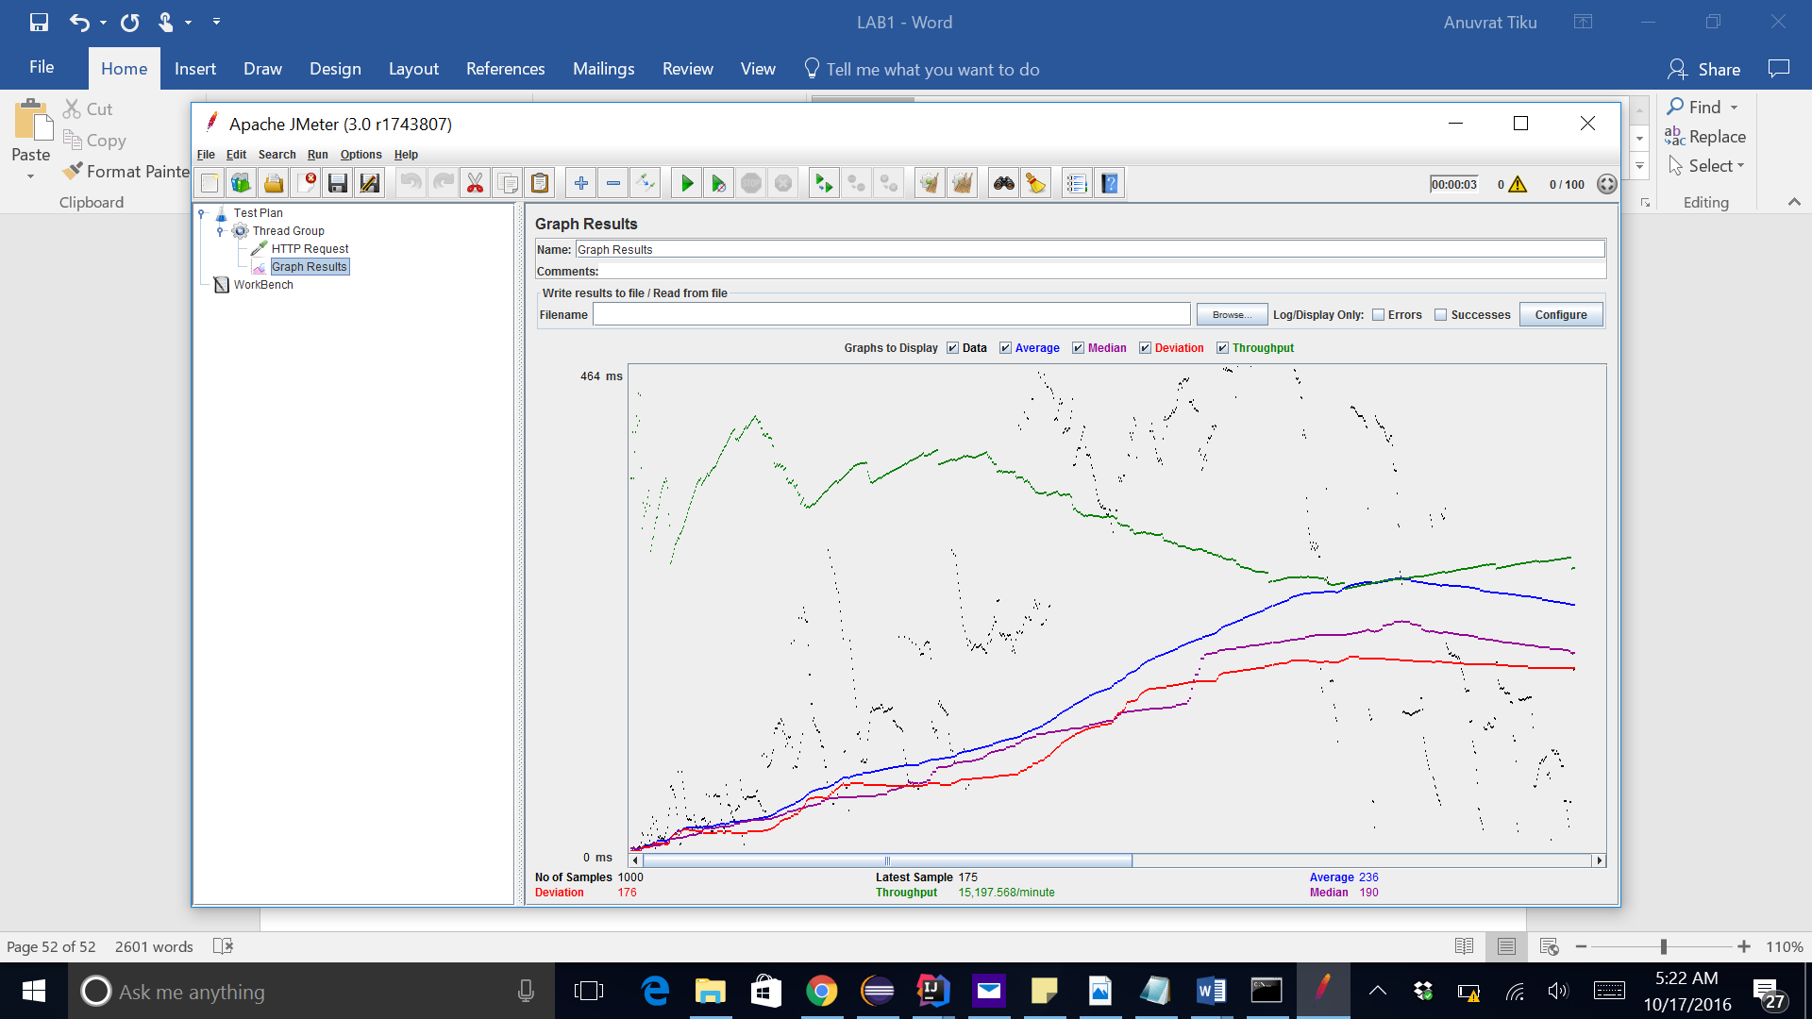

My observation is that that the more the number of concurrent calls the better the performance. Eg 5000 random calls were very in efficient. We can see as the loop count increases, the efficiency becomes better.